2014 State Damage Prevention Program Grant Final Report
CFDA Number: 20.720

Award Number: DTPH5614GPPS15
Project Title: New Jersey Board of Public Utilities State Damage Prevention Grant
Date Submitted: December 4, 2015
Submitted by: Michael Stonack

Specific Objective(s) of the Agreement

Under this grant agreement, the NJBPU will enforce:
▪ Laws and regulations of the damage prevention process

Workscope

Under the terms of this grant agreement, the Recipient will address the following elements listed in the approved application as stated in 49 U.S.C. §60134 (b).
▪ Element 7 (Enforcement): Enforcement of State damage prevention laws and regulations
for all aspects of the damage prevention process, including public education, and the use of
civil penalties for violations assessable by the appropriate State authority.

Accomplishments for this period (Item 1 under Article IX, Section 9.01 Final Report: “A comparison of actual accomplishments to the objectives established for the period.”)

The New Jersey Board of Public Utilities ("NJBPU") used the 2014 SDP Grant funds to offset salary and expenses for a damage prevention compliance and complaint investigator for its damage prevention program. The NJBPU implemented a new Damage Prevention / One Call database in 2014 to track underground facility damages, damage and non-compliance investigations, enforcement actions, and settlements (civil penalties) of the enforcement actions. This Grant project focused on natural gas facility damages, although other utility damages were also reviewed and associated enforcement actions were taken. Natural gas facility damage locations and related enforcement actions were GIS mapped and reviewed on a statewide basis. The damage prevention compliance enforcement and complaint investigator funded by this SDP Grant conducted inspections of probable non-compliance and complaints with regard to the New Jersey Underground Facility Protection Act ("Act"), issued probable non-compliance enforcement actions, addressed responses to non-compliance enforcement actions, determined proposed enforcement penalties with other damage prevention staff for probable non-compliance with the Act, and tracked probable non-compliance and complaint inspections and actions through the NJBPU database. Utilizing the Grant funding, non-compliance investigations were increased, additional non-compliance enforcement actions were processed, and the NJBPU damage prevention program was enhanced. This project directly affected Element 7 (Enforcement) of the NJBPU Damage Prevention Program.

Table 1 on page 2 provides a multiyear review of total gas facility damages and damages that occurred as a result of locates not being requested (no calls). In addition, Chart 1 on page 2 shows gas facility damages per 1,000 incoming ticket locate requests. This chart shows an overall declining trend over the years. Calendar year (“CY”) 2015 data through October 31, 2015, indicated 522,439 incoming tickets and 2.93 gas excavation damages per 1,000 incoming tickets. Table 1 and Chart 1 will be updated at the end of CY 2015.

Table 1 - Gas Facility Damages in New Jersey
Year | Total Damages | Locate-Not-Requested Damages
2009 | 1,654 | 604
2010 | 1,724 | 497
2011 | 1,637 | 566
2012 | 1,555 | 579
2013 | 1,836 | 643
2014 | 1,772 | 522
2015 | *1,533 | *802
* CY 2015 data through October 31, 2015.

Chart 1 Gas Facility Damages and Damages/1000 Tickets in New Jersey (2009-2014)
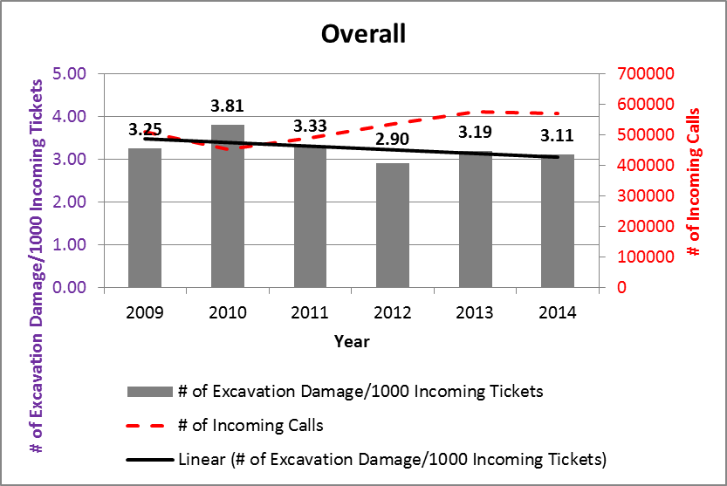
Table 2 on page 3 illustrates total damage cases by month for all underground utilities entered into the NJBPU database for review and those cases that were opened for investigation during the Grant period. The total cases entered for review also include locate not requested cases (no calls) that did not result in damages. These cases are ones where staff investigation found excavators digging without calling NJ One Call for a locate request or where a complaint was submitted against an excavator who was digging without underground facilities being marked. As the totals indicate, 32 percent (1,006 / 3,163) of all damages cases entered into the database were opened for investigation during the Grant period.

Table 2 - Case Investigations (All Utilities) by Month

Year | Month | Entered for Review / Opened for Investigation
2014 | October | 485 / 179
2014 | November | 289 / 76
2014 | December | 148 / 22
2015 | January | 308 / 57
2015 | February | 93 / 47
2015 | March | 91 / 66
2015 | April | 356 / 140
2015 | May | 275 / 117
2015 | June | 249 / 79
2015 | July | 475 / 61
2015 | August | 221 / 72
2015 | September | 173 / 90
Total 3,163 / 1,006

Table 3 below illustrates total gas facility damage cases entered into the database for review and those cases that were opened for investigation during the Grant period. The total cases entered for review also include locate not requested cases (no calls) that did not result in damages. These cases are ones where staff investigation found excavators digging without calling NJ One Call for a locate request or where a complaint was submitted against an excavator who was digging without underground facilities being marked. Fifty nine (59) percent (1,868 / 3,163) of all underground facility damages were gas facility damages. As the totals in Table 3 indicate, 31 percent (581 / 1,868) of gas damages cases entered into the database were opened for investigation during the Grant period.

Table 3 - Case Investigations (Gas Facilities) by Month

Year | Month | Entered for Review / Opened for Investigation
2014 | October | 204 / 82
2014 | November | 141 / 41
2014 | December | 123 / 47
2015 | January | 88 / 23
2015 | February | 49 / 38
2015 | March | 128 / 34
2015 | April | 183 / 116
2015 | May | 218 / 19
2015 | June | 215 / 25
2015 | July | 210 / 61
2015 | August | 168 / 76
2015 | September | 141 / 19
Total 1,868 / 581

Table 4, the Non-Compliance Enforcement Status Report on pages 4 and 5, illustrates the status and tracking of damaged gas facility cases being investigated by NJBPU staff for possible enforcement actions. The information depicted in the report was compiled using the NJBPU damage prevention database and represents gas facility damages that occurred during the period of September 15, 2015, through September 30, 2015.

Table 4 - Non-Compliance Enforcement Status Report

Quantifiable Metrics/Measures of Effectiveness (Item 2 under Article IX, Section 9.01 Progress Report: “Where the output of the project can be quantified, a computation of the cost per unit of output.”)

The work performed by the investigator under the 2014 SDP Grant project was very effective in accomplishing the Grant objectives of enhancing compliance and complaint investigations, and enforcement actions where appropriate. As indicated in the enforcement settlement report, Table 5 on page 6, enforcement settlements for the Grant period totaled $1.93 million, which are directly related to the work performed by the damage prevention compliance and complaint investigator. Of the $1.93 million total, $850,000 was attributable to one natural gas incident that was the result of an excavation damage. The enforcement settlement report also shows the number of letters of inquiry (LOI) and number of notices of violation (NOV) that were sent to excavators and operators by damage prevention staff during the Grant period.

Table 5 – Enforcement Settlement Report

Issues, Problems or Challenges (Item 3 under Article IX, Section 9.01 Final Report: “The reasons for slippage if established objectives were not met. “)

The established objectives for the Grant project were achieved. However, the project costs were lower than anticipated due to a delay in the NJBPU assigning the Damage Prevention Investigator to a permanent position. This issue was resolved; however, the investigator was not assigned a permanent position until September 28, 2015, after the date the Grant period ended.

Final Financial Status Report

The final financial report has been sent as a separate attachment to the AA. See Form SF-425, Federal Financial Report, submitted by PI on December 4, 2015.

Project Costs

Personnel (Damage Prevention Investigator)…1,737.75 Hours @$26.73/Hour……...… 46,450.06
Fringe Benefits…………………………………………………………………………………… 0.00
Travel……………………………………………………………………………………………… 0.00
Equipment…………………………………………………………………………………………. 0.00
Supplies……………………………………………………………………………………………. 0.00
Contractual……………………………………………………………………………………….. 0.00
Other……………………………………………………………………………………………….. 0.00
Indirect…………………………………………………………………………………………….. 0.00

Total Project Costs…………………………………………………………..…$46,450.06
Project Costs paid with Mid-Term Progress Report ………………………………24,892.31
Project Costs requested with Final Progress Report…………………………$21,557.75

Requests of the AOR and/or PHMSA

No actions requested at this time.

