Quarterly Report – Public Page

Date of Report: 2nd Quarterly Report-March 31, 2023
Contract Number: 693JK322RA0001
Prepared for: DOT/PHMSA
Project Title: Determining the Required Modifications to Safely Repurpose Existing Pipelines to Transport Pure Hydrogen and Hydrogen-Blends
Prepared by: Engineering Mechanics Corporation of Columbus
Contact Information: Kenneth Bagnoli (kbagnoli@emc-sq.com)
For quarterly period ending: March 31, 2023

1: Items Completed During this Quarterly Period:
The following items were delivered in this quarterly period. Note that the 1st quarterly report was not invoiced when delivered and is included in this quarterly invoice.
Item # | Task # | Activity/Deliverable | Title | Federal Cost | Cost Share
1 | 1 | Literature Review | Perform Literature Review | $14,000 | $0
3 | 8 | 1st Quarterly Status Report | Submit 1st quarterly report | $2,500 | $0
7 | 8 | 2nd Quarterly Status Report | Submit 2nd quarterly report | $2,500 | $0

2: Items Not-Completed During this Quarterly Period:
Item # | Task # | Activity/Deliverable | Title | Federal Cost | Cost Share
2 | 5 | Identify potential limitations in components and pipeline conditions | Potential component and condition limitations identified | $8,000 | $0
3 | 8 | Assess critical flaw sizes and respective detection thresholds | Critical flaw sizes and thresholds assessed | $25,000 | $20,000

3: Project Financial Tracking During this Quarterly Period:
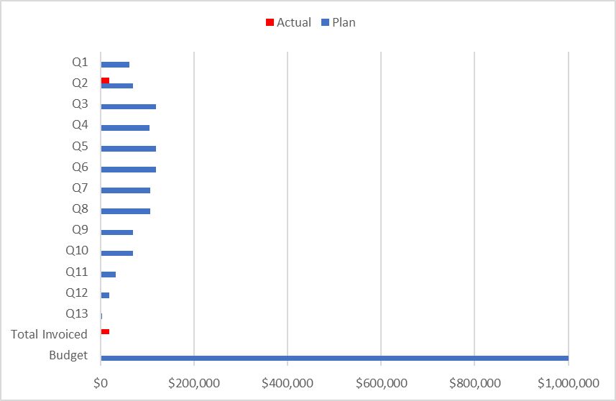

4: Project Technical Status –
Work during this quarter has focused on Task 1, Task 5. Literature sources have been obtained and are being summarized. The literature review Task 1 includes the following topics:

- Identification of primary threats and
- Phase field modeling of hydrogen diffusion and damage
- Microstructure and chemistry of pipeline steels, defect types, welds, etc.
- Properties of vintage pipelines
- Background on hydrogen embrittlement mechanisms of steel and non-metallic materials
- Thermodynamic data on hydrogen permeability, solubility, and diffusivity of steels
- Hydrogen solubility and diffusion in stress fields around cracks and other discontinuities
- Weld simulation to assess residual stresses around fillet and full penetration welds
- Application of continuum damage mechanics for evaluating structural integrity
- Hydrogen strain rate effects on fracture toughness
- Hydrogen effects on stress-strain behavior and ductility
- Strain limits for dents, gouges, and local thin areas
- Effect of hydrogen on tolerable flaw size (K_{IC-H}) and initiation of subcritical crack growth under constant load (K_{IH})

Work has begun on Task 5 developing the process for assessment of critical flaw sizes and detection. The strategy for this portion of the project will be to utilize a phase field modeling approach for simulating hydrogen embrittlement developed at University of Akron (Professor Gao). This methodology has been shown to successfully describe the migration of hydrogen to region of high hydrostatic stress. The effects of hydrogen on localized plasticity are then incorporated to model either reduced resistance to crack growth or development of damage due to high strain. For this project, damage associated with pipelines has been separated into two categories, cracks, and region of high strain (e.g., dent, gouge, local corrosion). These two areas encompass most of the important integrity concerns for repurposing vintage pipelines. The modeling work will begin by looking at cracks in test specimens. The geometries will be the compact tension C(T) and single edge notched tension SEN(T) specimens. The former is chosen as there exists data on the hydrogen effects on fracture toughness from this geometry. The latter specimen is used to simulate a mechanical constraint similar to a flaw in a pipeline. Once this is complete, the routines developed by Professor Gao will be used by Emc2 to examine axial flaws in a pipeline. To simulate strain induced damage, blunt notched specimen geometries will be used with varying acuities to examine differences in hydrogen concentration due to various stress fields. Once this model has been calibrated, it will then be used by Emc2 to evaluate dent and local corrosion areas. The results of the modeling efforts will be used to infer the critical flaw sizes in the presence of hydrogen.

This work is scheduled to begin in April 2023.

5: Project Schedule –

