Quarterly Report – Public Page

Date of Report: 7th Quarterly Report – July 31, 2023
Contract Number: #693JK32110008POTA
Prepared for: DOT and Co-funders
Project Title: Advancement of Through-tubing Casing Inspection for Underground Storage Wells
Prepared by: Pipeline Research Council International, Inc.
Contact Information: Carolyn Descoteaux (CDescoteaux@prci.org)
For quarterly period ending: June 30, 2023

1: Items Completed During this Quarterly Period:

Item # | Task # | Activity/Deliverable | Title | Federal Cost | Cost Share
11 | 2 | Conduct logging test round #2 | Results to be included in the quarterly report | $ 77,755.6 | $ 77,755.6
15 | 3 | Develop preliminary framework for reliability-based casing integrity management | Results to be included in the quarterly report | $ 46,809.6 | $ 46,809.6
16 | 5 | 7th quarterly status report & project management | Submit 7th quarterly report | $6,365.12 | $6,365.12

2: Items Not Completed During this Quarterly Period:

Item # | Task # | Activity/Deliverable | Title | Federal Cost | Cost Share
13 | 2 | Tool performance evaluation for logging test round #2 | Results to be included in the quarterly report | $31,102.24 | $31,102.24

3: Project Financial Tracking During this Quarterly Period:

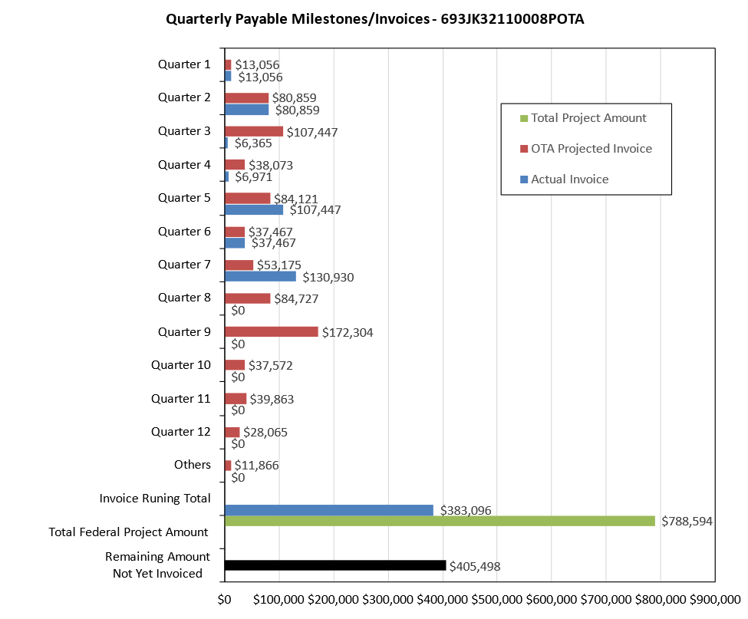

4: Project Technical Status:

[Item #11] [Task #2] [Conduct logging test round #2] [Results to be included in the quarterly report]

Baker Hughes, Schlumberger and GOWell conducted the logging tool test at C-FER between June 12th and June 28th 2023. Tests were completed successfully and were within the 3-day plan for each vendor. Details of the test well setup are described in Appendix A of this quarterly report. The results of the reported metal-loss features submitted by the three vendors are included in Appendix B of this quarterly report.

[Item #15] [Task #3] [Develop preliminary framework for reliability-based casing integrity management] [Results to be included in the quarterly report]

A preliminary workflow for casing integrity assessment using through-tubing inspection is proposed and described in Appendix A of this quarterly report. The proposed preliminary workflow was discussed with the Technical Advisory Panel (TAP) in the quarterly project meeting. The preliminary workflow is subject to further refinement and revision upon receiving further feedback from the TAP.

[Item #16] [Task #5] [7th quarterly status report & project management] [Submit 7th quarterly report]

A quarterly TAP meeting is held on June 29th, 2023. This meeting reviewed the overall project progress and forecasted the work plan for the next quarter.

5: Project Schedule:

A request for six months no-cost project schedule extension has been submitted to PHMSA.

Anticipated schedule of delayed tasks:

[Item #13] [Task #2] [Tool performance evaluation for logging test round #2] [Results to be included in the quarterly report]

The tool performance evaluation for the 2nd round of logging tool tests is expected to be complete in Q8 2023. The evaluation results are expected to be reported in the eighth quarterly report.

