**CAAP 2nd Annual Report**

Date of Report: *10/12/2023*

Prepared for: *U.S. DOT Pipeline and Hazardous Materials Safety Administration*

Contract Number: *693JK32150001CAAP*

Project Title: *Pipeline Risk Management Using Artificial Intelligence-Enabled Modeling and Decision Making*

Prepared by: *Bingyan Cui (PhD student), Emad Farahani (PhD student), Dr. Hao Wang (PI), Dr. Qindan Huang (Co-PI)*

Contact Information: Hao Wang, [hw261@soe.rutgers.edu](mailto:hw261@soe.rutgers.edu), 848-445-2874

Qindan Huang, [qindan.huang@marquette.edu](mailto:qhuang@uakron.edu), 414-288-6670

For quarterly period ending: 10/1/2022 - 9/30/2023

**Business and Activity Section**

# Contract Activity

* Contract Modification

N/A

* Student Mentoring

Two PhD students are mainly working on the project tasks. The PhD student at Rutgers University, Bingyan Cui, led the work on data analysis of ILI reports and development of machine learning models for defect growth prediction. The PhD student at Marquette University, Emad Farahani,led the work on development of Bayesian statistics model for defect growth prediction.

* Educational Activities

The PI introduced the knowledge of pipeline integrity management system in the graduate course – *Infrastructure Management System* taught at Rutgers University.

The Co-PI introduced the knowledge of pipeline failure prediction and risk management in the graduate course - *Engineering Risk Analysis* at Marquette University.

* Outreach Activities

The research team collected pipeline in-line inspection (ILI) data from the industry partners for developing defect growth models and shared the analysis findings with the industry partner.

The following paper has been published based on project findings:

*Cui, B.Y. and H. Wang*, Analysis and Prediction of Pipeline Corrosion Defects Based on Data Analytics of In-Line Inspection, Journal of Infrastructure Preservation and Resilience, 2023, Vol. 4, Article No.14*

*https://doi.org/10.1186/s43065-023-00081-w*

# Financial Summary

* Federal Cost Activities

The salary of PIs and graduate students and the tuition of graduate students are partially charged from the project during this reporting period.

* Cost Share Activities

Cost share contribution includes PIs’ academic salary and indirect costs at Rutgers University and Marquette University during this reporting period.

# Project Schedule Update

The updated schedule of research tasks is shown in the following table.

|  |  |  |  |  |  |  |  |  |  |  |  |  |
| --- | --- | --- | --- | --- | --- | --- | --- | --- | --- | --- | --- | --- |
| **Tasks** | **Year 1** | | | | **Year 2** | | | | **Year 3** | | | |
| ***Task 1*** *Literature Review* |  |  |  |  |  |  |  |  |  |  |  |  |
| ***Task 2*** *Data Collection from Literature and Industry Partners* |  |  |  |  |  |  |  |  |  |  |  |  |
| ***Task 3*** *Data-Driven Probabilistic Modeling of Pipeline Defects* |  |  |  |  |  |  |  |  |  |  |  |  |
| ***Task 4*** *Quantification of Probability of Failure* |  |  |  |  |  |  |  |  |  |  |  |  |
| ***Task 5*** *Decision Making with Reinforcement Learning* |  |  |  |  |  |  |  |  |  |  |  |  |
| ***Task 6*** *Final Report and Presentation* |  |  |  |  |  |  |  |  |  |  |  |  |

More time was spent on Task 3 Data-Driven Probabilistic Modeling of Defects due to extensive data analysis of multiple datasets from industry partners and literature. Task 4 Quantification of Probability of Failure is started in this quarter. A one-year NCE is expected to be requested in year 3 of the project.

# Status Update of the 4th Quarter Technical Activities

**Identification of Corrosive Soil Environment as Anomaly Detection**

Anomaly detection is to identify unusual events or conditions that may pose a threat to the safe and efficient operation of pipelines. By detecting potential issues at an early stage, anomaly detection enables timely maintenance and reducing the risk of accidents. An effective anomaly detection system helps pipeline operators identify potential issues before they become critical, allowing for planned maintenance instead of expensive repairs. This proactive approach reduces maintenance costs and improves the overall efficiency of pipeline operations.

In this section, anomaly detection is used to identify the soil environment that may cause corrosion, in other words corrosive soil environment. In the ILI dataset, inspection locations with corrosion were considered as defects, while those without corrosion were classified as normal. Consequently, the ILI dataset was divided into two classes. For locations with multiple defects, a single data record was preserved, effectively eliminating duplicate data points. Therefore, the original dataset, consisting of approximately 35,000 samples, was refined to 9,000 samples. Similarly, the cleaned zone-based dataset contained about 700 samples.

Various machine learning methods were used to process large amounts of ILI inspection data with the corresponding soil properties, including conditional generative adversarial neural networks (cGAN), XGBoost, random forest, decision trees, AdaBoost, and etc. These techniques can improve the accuracy and efficiency of anomaly detection and help prioritize the areas for further investigation or maintenance.

## *Anomaly detection without handling imbalanced data*

The number count of normal and defect data samples in original and zone-based dataset is shown in Figure 1. It can be seen that the number of normal samples was much larger than defect samples in the original dataset. However, in zone-based dataset, the number of defect samples was greater than normal samples.

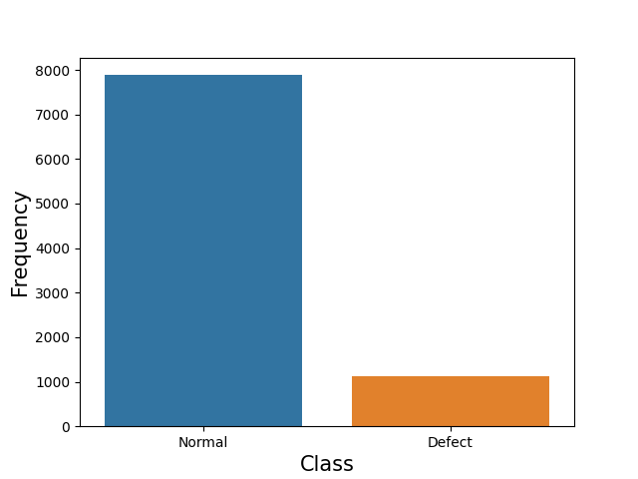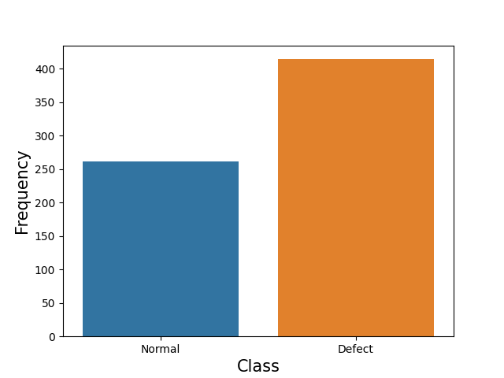

(a) (b)

Figure 1 Number counts of normal and defect data (a) original dataset, (b) zone-based dataset.

To classify normal and defect classes, accuracy, precision, recall and F1 score were usually used to evaluate the model performance. Accuracy is the percentage of correctly classified samples out of all samples in the testing dataset. Precision is the percentage of truly positive samples out of all predicted positive samples. Recall is the percentage of truly predicted positive samples out of all truly positive samples. These metrics can be calculated as Eq. (1) to (3).

 (1)

 (2)

 (3)

where, *TP* is number of positive samples correctly predicted as positive; *TN* is number of negative samples correctly predicted as negative; *FP* is number of negative samples incorrectly predicted as positive; *FN* is number of positive samples incorrectly predicted as negative.

The comparative analysis of the original dataset, based on classification accuracy using various machine learning techniques, is depicted in Figure 2. Although most methods achieved accuracy above 80%, it is crucial to consider another significant problem. The precision and recall values of these models were quite low, as shown in Table 1. This indicates that the machine learning methods were biased towards the majority class (normal class) as they aimed to minimize overall error. Therefore, their performance in detecting anomalies was poor, resulting in a high rate of false negatives. The primary cause of this issue can be attributed to the imbalanced nature of the original dataset.

Imbalanced datasets pose a significant challenge in anomaly detection because the distribution of normal and anomalous instances is highly skewed. Anomalies, by definition, are rare events that deviate from the norm. Consequently, in an imbalanced dataset, the majority of data points belong to the normal class, while only a small fraction represents anomalies. Common evaluation metrics like accuracy can be misleading in the context of imbalanced datasets, as a model that predicts only the majority class will still achieve high accuracy. In anomaly detection, it is important to focus on metrics that account for both false negatives and false positives, such as precision and recall.

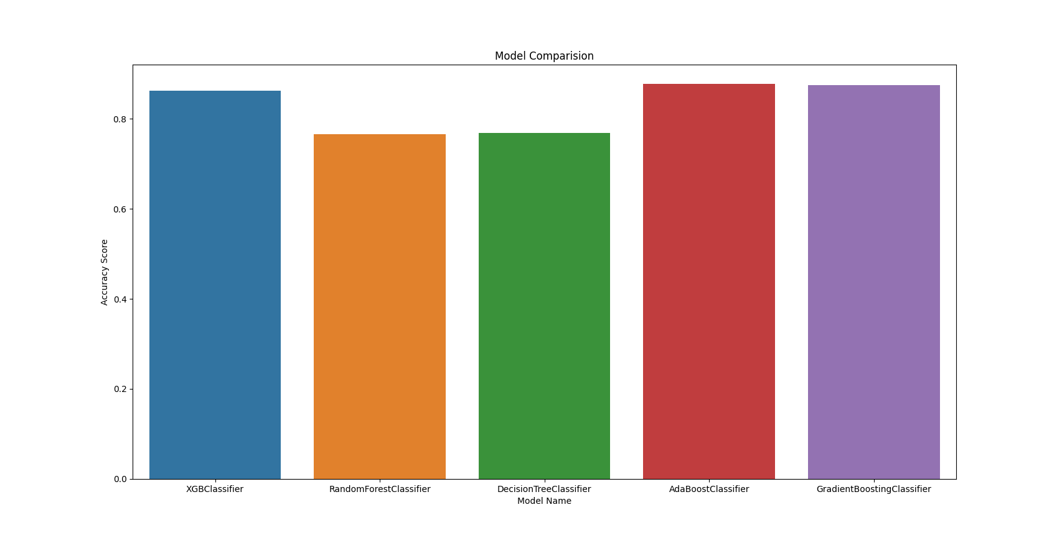

Figure 2 Comparison of accuracy on original dataset with different machine learning methods.

Table 1 Machine learning model performance on anomaly detection for original dataset.

|  |  |  |  |  |  |
| --- | --- | --- | --- | --- | --- |
| Metrics | XGBoost | Random Forest | Decision Tree | AdaBoost | GradientBoosting |
| Accuracy | 0.862222 | 0.765333 | 0.767556 | 0.876444 | 0.873778 |
| Recall | 0.007194 | 0.021583 | 0.025180 | 0.000000 | 0.003597 |
| Precision | 0.055556 | 0.022901 | 0.027027 | 0.000000 | 0.125000 |

A comparative analysis was also conducted on the zone-based dataset. Figure 3 illustrates the accuracy results for five machine learning methods, while Table 2 provides a detailed overview of their recall and precision values. As observed in the table, both recall and precision values were comparatively high, suggesting that the impact of imbalance on the zone-based dataset might not pose a significant problem.

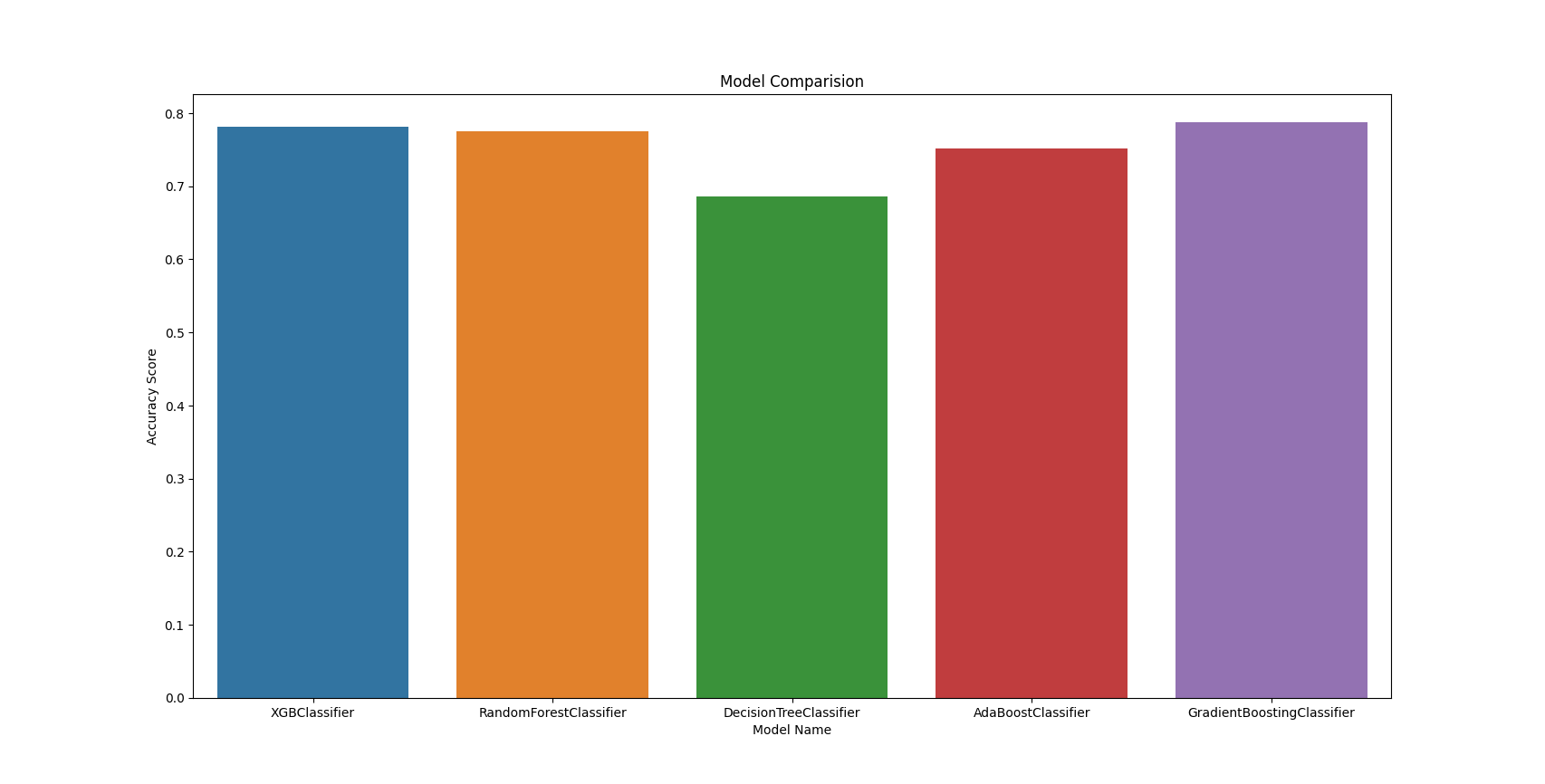

Figure 3 Comparison of accuracy on zone-based dataset with different machine learning methods.

Table 2 Machine learning model performance on anomaly detection for zone-based dataset.

|  |  |  |  |  |  |
| --- | --- | --- | --- | --- | --- |
| Metrics | XGBoost | Random Forest | Decision Tree | AdaBoost | GradientBoosting |
| Accuracy | 0.781065 | 0.775148 | 0.686391 | 0.751479 | 0.786982 |
| Recall | 0.819048 | 0.809524 | 0.752381 | 0.771429 | 0.800000 |
| Precision | 0.826923 | 0.825243 | 0.745283 | 0.818182 | 0.848485 |

## *Anomaly detection with handling imbalanced data*

To address the problem of imbalanced data, different techniques can be used, such as resampling methods, algorithmic modifications, and ensemble methods. In this study, to increase the number of minority class in the dataset, oversampling methods were used. This approach adds more samples of the minority class, either by duplicating existing samples or generating synthetic ones. Two methods, Synthetic Minority Over-Sampling Technique (SMOTE) and Conditional Generative Adversarial Networks (cGANs), were employed in the following.

SMOTE is an approach used to address the problem of imbalanced datasets by generating synthetic samples for the minority class. Firstly, it will select random samples from the minority class. Then, it will identify k nearest neighbors from the minority class for the chosen sample. Next, SMOTE selects a random neighbor from the identified k neighbors and calculates the difference between the feature values of the selected neighbor and the original minority sample. A random number between 0 and 1 is multiplied by the difference calculated in the previous step. The resulting value is added to the feature values of the original minority sample, generating a new synthetic sample. The process is repeated until the desired level of balance is achieved, resulting in a new dataset with synthetic minority samples. By generating synthetic samples instead of duplicating existing ones, SMOTE reduces the likelihood of overfitting, allowing the model to perform better on unseen data.

cGANs are an extension of the original GAN framework, designed to generate data samples conditioned on certain information, such as class labels. In this study, cGANs were used to address imbalanced datasets by generating synthetic samples for the defect class. A cGAN has two components: a generator (G) and a discriminator (D). The generator creates synthetic samples, while the discriminator evaluates their authenticity. Both components receive class label information during training, allowing them to condition their behavior on the given class labels. The training process consists of alternating between training the discriminator and the generator. The discriminator is trained to correctly classify real samples from the dataset as real and synthetic samples generated by the generator as fake. The generator is trained to create synthetic samples that can deceive the discriminator into classifying them as real. During the training process, the generator improves its ability to create realistic synthetic samples for the minority class. Once the training is complete, the generator can produce synthetic samples for the minority class. The generated synthetic samples are added to the original dataset, resulting in a more balanced dataset. By generating synthetic samples for the minority class, cGANs can help mitigate the class imbalance issue and improve the performance of machine learning models on imbalanced datasets.

Datasets before and after using oversampling methods can be seen in Figure 4. It is obvious that the number of defect class and normal class became more equivalent after oversampling. Using five machine learning methods one new datasets, the model performance can be seen in Table 3 and Table 4. It should be noted that only the best performance among five models was listed in the tables. And results without oversampling were used as the baseline.



(a)



(b)

Figure 4 Number of two classes before and after oversampling (a) original dataset, (b) zone-based dataset.

Table 3 Comparison of model performance before and after using oversampling original datasets.

|  |  |  |  |
| --- | --- | --- | --- |
| Metrics | Baseline | SMOTE | cGANs |
| Accuracy | 0.874 | 0.782 | 0.867 |
| Recall | 0.004 | 0.544 | 0.500 |
| Precision | 0.125 | 0.301 | 0.308 |

Table 4 Comparison of model performance before and after using oversampling zone-based datasets.

|  |  |  |  |
| --- | --- | --- | --- |
| Metrics | Baseline | SMOTE | cGANs |
| Accuracy | 0.781 | 0.800 | 0.848 |
| Recall | 0.719 | 0.750 | 0.765 |
| Precision | 0.827 | 0.913 | 0.903 |

Based on the results for the original dataset, the baseline model achieves the highest accuracy, followed by cGANs, and then SMOTE. However, accuracy may not be the suitable metric to consider due to the imbalanced data. In terms of recall and precision, both SMOTE and cGANs outperform the baseline model. Although the values for recall and precision remain relatively low, their performance were significantly better than that of the baseline model. This indicates that employing oversampling methods to address the imbalance can enhance the anomaly detection model's performance.

Regarding the results for the zone-based dataset, all methods demonstrate satisfactory performance. However, cGANs achieve superior results, as this method could improve recall and precision without significantly affecting accuracy.

**Quantification of Probability of Failure**

## *Failure modes*

The pipeline system under consideration is pressurized and may experience failure through two distinct general modes: small leak (event S) and burst (event B) while burst failure mode can be further categorized as large leak (event L) and rupture (event R). If the through-wall defect resulting from the burst spreads unstably along the axial direction of the pipeline, the failure is called rupture, otherwise is called large leak. Therefore, using algebra of events, B=L ∪ R where large leak and rupture are two mutually exclusive events, i.e., L ∩ R=∅, and consequently, *P*(B) = *P*(L) + *P*(R).

* Small leak

The small leak failure mode is defined as when a corrosion defect reaches a critical depth of the pipe wall thickness. This critical depth is assumed to be 0.8 times the pipe wall thickness in this study. Thus, the probability of small leak failure is determined as:

$P_{f,S}\left(t\right)=P\left({0.8 d}_{w}-d\left(t\right)≤0\right)$ (4)

in which *d*w = pipe wall thickness and *d*(*t*) = maximum depth of a corrosion defect at time *t*, which is predicted from the obtained growth model.

* Burst

The burst failure mode occurs when the internal working pressure exceeds the pressure capacity of the pipeline, resulting in plastic collapse of the pipeline. This failure mode is, therefore, influenced by the presence of corrosion defects, which contribute to the decay of the pressure capacity. The probability of burst failure mode can mathematically be expressed as:

$P_{f,B}\left(t\right)=P\left(C_{b}(t)-D_{p}≤0\right)$ (5)

where *C*b = burst pressure capacity which is a function of the defect dimension and can be evaluated based on modified ASME B31G as:

$C_{b}(t)=\frac{2\left(σ_{min,{y}}+68.95\right) d_{w}}{d_{O}}\left[\frac{1-0.85\frac{d\left(t\right)}{d_{w}}}{1-0.85 \frac{d\left(t\right)}{d_{w}} F^{-1}}\right]$ (6)

where *σ*min,y = specified minimum yielding stress (MPa) and *d*O = outer diameter of the pipeline, *F* = Folias factor, which can be determined by:

$F=\left\{\begin{aligned}&\sqrt{1+0.6275\frac{l^{2}\left(t\right)}{d_{O}d_{w}}-0.003375\frac{l^{4}\left(t\right)}{d_{0}^{2}d_{w}^{2}}} \frac{l^{2}\left(t\right)}{d_{O}d_{w}}≤50 \\ &3.3+0.032\frac{l^{2}\left(t\right)}{d_{O}d_{w}} \frac{l^{2}\left(t\right)}{d_{O}d_{w}}>50\end{aligned}\right.$ (7)

More recently, Kere and Huang (2022) developed probabilistic failure pressure models for pipelines with single corrosion defect and, based on the relation proposed by Phan et al. (2017), proposed the following relation for the case when 392 ≤ *σ*u < 600 MPa:

$C_{b}\left(t\right)=1.8469+1.0281\left(\frac{2 d_{w}σ_{u}}{d_{O}}\left[1-\frac{1.24678{d\left(t\right)}/{d_{w}}}{1+12.6739{d_{w}}/{L\left(t\right)}}\right]\right)+σ·ε$ (8)

in which *σ*u = ultimate tensile strength of the pipe material in MPa and *σ*= model error variance of 1.8442 MPa.

* Rupture

The model proposed by Kiefner et al. (1973) for pressurized pipes containing through-wall defect is utilized in this study to calculate the rupture pressure, *C*rp, as follows:

$C_{rp}(t)=\frac{2\left(σ_{min,{y}}+68.95\right) d_{w}}{{F d}_{O}}$ (9)

Therefore, the probability of rupture failure mode can be estimated by:

$P_{f,R}\left(t\right)=P\left(C_{rp}(t)-D_{p}≤0\right)$ (10)

* Large leak

As mentioned above, *P*(B) = *P*(L) + *P*(R). Therefore, the probability of failure corresponding to the large leak can simply be obtained by *P*(L) = *P*(B) − *P*(R).

# *System reliability*

To assess the reliability of the pipeline system, each kilometer of the pipeline is treated as an individual sub-system and the probability of failure per kilometer is estimated. Each sub-system is treated as a series system in which the failure of any defect within the sub-system results in the failure of the entire sub-system. The probability of failure for a given sub-system can therefore be calculated using:

$P_{f}\left(t\right)=1-\prod_{j=1}^{N_{d}}{\left[1-P_{f, j}\left(t\right)\right]}$ (11)

where *Pf*, *j* = failure probability of the *j*th detected defect, and *N*d = number of defects in the sub-system under evaluation. In general, the estimated probability of failure should be compared to a predefined target value. If the estimated probability of failure exceeds this target value, it suggests that appropriate actions such as repair or replacement should be taken, for the corresponding section of the pipeline at that particular point in time. This helps to ensure the continued safe and reliable operation of the pipeline system.

In this paper, the probability of failure of the first kilometer of the inspected pipeline is estimated for the four failure modes of small leak, burst, rupture, and large leak by first-order reliability method (FORM) utilizing the FERUM application in MATLAB software, based on the damage sizes predicted from the proposed model.

The uncertainties taken into account in the reliability analysis include the model errors in the prediction models, statistical uncertainties in the model parameters (as summarized in Table 5), mechanical and geometrical properties of the pipeline, working pressure of the pipeline, and finally the model errors of capacity equations. Besides, the corrosion depth and length initiation time, *t*0d and *t*0L, were considered as Gamma random variables in which the shape parameter is the unique order of each defect and scale parameter is constant for all defects. Note that the model selection has been done separately for depth and length prediction models, which results in two sets of soil properties for the two models, as shown in Table 5. However, such results are possible considering different soil properties may influence the corrosion depth and length evolution differently.

Table 6 summarizes the considered random variables along with the corresponding statistics, where *d*O = pipeline outer diameter, *d*w = pipeline wall thickness, *σ*min,y =pipeline steel specifiedminimum yield strength, *P*d = workingpressure, *ε =* growth and capacity models error*, t*0,d = depth growth initiationtime, and *t*0,L = Length growth initiationtime, . In addition, the values of soil properties were considered as deterministic random variables with no uncertainty.

# *Preliminary Analysis Results*

Figure 5 presents the probabilities of failure for the different failure modes of the investigated 1-km pipeline segment, as calculated using Eq. (11). The solid lines show the probability of failure when only statistical uncertainties in the random variables are taken into account. However, the dashed lines show the confidence bound for the probability of failure considering the uncertainties in the model parameters in the defect growth models. As anticipated, the calculated probabilities of failure show a monotonic increase over time, as a consequence of corrosion development.

To determine the acceptability of these failure probabilities, they can be compared to predefined target values that represent the required level of risk or reliability for the pipeline system. Note that such required level usually depends on the class location, and the requirement is stricter for a higher safety class location. For example, Det Norske Veritas (DNV) standard prescribes the ultimate limit state target failure probabilities corresponding to the three safety classes of low, medium and high as 10−3, 10−4, and 10−5, respectively. According to Figure 5, by the year 2035 (almost 65 years after pipeline installation), the upper limit of estimated probability of failure for small leak and the probability of failure of burst and large leak reach the target value for high and medium safety class, respectively, whereas that of rupture failure mode remains below the target levels until 2070 (almost 100 years after pipeline installation).

In view of the wider confidence bound for probability of failure in the small leak failure mode, it is concluded that this quantity is, compared to others, more sensitive to the model parameters and therefore gathering more information and updating the model is more crucial for this failure mode which is only dependent on depth growth. It is worth noting that 128 defects were detected in the investigated segment of the pipeline and this segment is the fifth defective segment of the pipeline considering the number of detected defects. It is clear that the probability of failure of a series system is highly influenced by the number of components (defects) and therefore this segment is one of the most critical segments of the pipeline, with a high system probability of failure.

Table 5 Posterior distribution statistics of model parameters in the developed growth models

|  |  |  |  |  |  |  |  |
| --- | --- | --- | --- | --- | --- | --- | --- |
|  | Param. | Variable | Mean | Stdv | Median | COV | geweke |
| depth | *θ*1,0 | Intercept | 5.989E-01 | 3.804E-02 | 6.049E-01 | 6% | 0.95 |
| *θ*1,1 | Soil Moisture | -1.847E+00 | 1.317E-01 | -1.869E+00 | -7% | 0.94 |
| *θ*1,2 | Resistance_1m | -3.195E-05 | 5.853E-05 | -3.622E-05 | -183% | 0.70 |
| *θ*1,3 | HCO3 | 6.141E-04 | 9.077E-04 | 6.258E-04 | 148% | 0.76 |
| *θ*2*,*0 | Intercept | -9.299E+00 | 2.495E-01 | -9.290E+00 | -3% | 0.98 |
| *θ*2,1 | Soil Moisture | 4.187E+01 | 1.392E+00 | 4.192E+01 | 3% | 0.99 |
| *θ*2*,*2 | Resistance_1m | -2.151E-04 | 1.245E-03 | -3.098E-04 | -579% | 0.73 |
| *θ*2*,*3 | SO4 | 3.313E-01 | 6.554E-01 | 2.634E-01 | 198% | 0.85 |
| *βD* | - | 6.939E-01 | 1.384E-02 | 6.946E-01 | 2% | 0.97 |
| *σD* | - | 1.989E-01 | 3.713E-03 | 1.986E-01 | 2% | 1.00 |
| length | *θ*1,0 | Intercept | 1.951E-01 | 5.938E-02 | 1.990E-01 | 30% | 0.93 |
| *θ*1,1 | HCO3 | 2.598E-03 | 4.295E-03 | 2.917E-03 | 165% | 0.81 |
| *θ*1,2 | Cl | 1.116E-03 | 5.197E-03 | 9.535E-04 | 466% | 0.85 |
| *θ*1,3 | Potential Redox | 9.787E-05 | 1.004E-04 | 1.008E-04 | 103% | 0.81 |
| *θ*2*,*0 | Intercept | -1.609E+01 | 1.662E+00 | -1.622E+01 | -10% | 0.96 |
| *θ*2,1 | HCO3 | 2.239E-01 | 8.341E-01 | 1.414E-01 | 372% | 0.75 |
| *θ*2*,*2 | Cl | 3.925E+00 | 9.096E-01 | 3.981E+00 | 23% | 0.87 |
| *θ*2*,*3 | Potential Redox | -8.740E-02 | 3.078E-02 | -8.492E-02 | -35% | 0.96 |
| *βL* | - | 1.884E-01 | 1.375E-03 | 1.889E-01 | 1% | 1.00 |
| *σL* | - | 7.862E-01 | 1.505E-02 | 7.852E-01 | 2% | 1.00 |

Table 6 Considered random variables and their statistics for reliability analysis

|  |  |  |  |
| --- | --- | --- | --- |
| Random variable | Distribution | Mean value | CoV |
| *d*O | Normal | 457.2 (18 in) | 3% |
| *d*w | Normal | 6.4008 mm (25.4 in) | 3% |
| *σ*min,y | Normal | 358.53 MPa (52 ksi) | 3% |
| *P*d | Normal | 5.5158 (800 psi) | 3% |
| *ε* | Normal | 0 | Stdv=1 (mm) |
| *t*0,d | Gamma | *β*d · *k*d (1) |  |
| *t*0,L | Gamma | *β*L · *k*L |  |
| (1)  *β*d = scale parameter in depth growth model· *k*d = shape parameter (order of defects) in depth growth model | | | |

|  |  |
| --- | --- |
|  |  |
| 1. Small leak | 1. Burst |
|  |  |
| 1. Rupture | 1. Large leak |

Figure 5 Time-dependent failure probability of studied subsystem for the considered failure modes

**Detailed Technical Results in the Report Period**

# (a) Background and Objectives in the Annual Report Period

The objective of 2nd year work is to analyze ILI data and develop defect growth models using Bayesian Neural Network (BNN) and power-law based probabilistic function.

# (b) Research Progress

The following provides the summary of work for each task. The detailed data and analysis can be found in the quarterly reports.

*Task 1 Literature Review – completed in year 1*

*Task 2 Data Collection from Industry Partners and Literature – completed in year 1*

*Task 3 Data-Driven Probabilistic Modeling of Pipeline Defect Generation and Growth*

The first set of ILI data from New Jersey was used to analyze the relationship between corrosion defects using data analytics. First, statistical analysis was performed on raw data to visualize distributions of corrosion depths and number of corrosions. Second, hierarchical clustering method was used to classify corrosion severity levels based on features of corrosion depth and estimated repair factor. The interaction effect between adjacent corrosions was considered. Machine learning methods, including k-nearest neighbor, support vector machine, random forest, and light gradient boosting machine were used to explore the relationship between the location parameters of adjacent corrosions and severity levels. Then, maximum corrosion depths and corrosion density were filtered from raw ILI data of multiple inspections, which were critical for pipeline failure prediction. Finally, distribution parameters were fitted to establish stochastic growth models on maximum corrosion depth and corrosion number density. This study presents a detailed approach on how to obtain valid information from ILI data in practice.

The second set of ILI data from Gulf of Mexico was used to develop defect generation and growth models for corrosion depth and length under the influences of soil environment. The following two methods are used:

* Bayesian Neural Network (BNN) is developed to predict defect growth and quantify uncertainty. As compared to ANN, BNN treats the learned parameters (weights and bias) as random variables instead of point estimates. Variational inference (VI) is implemented as a mathematical model of nonlinear mapping between inputs and outputs to interfere the space of parameters in the BNN. Model tuning is conducted by changing the number of layers and the number of units in each layer. Considering the corrosion defect grows over time, the parameter of corrosion time is introduced by assuming that the occurrence of defects follows a homogeneous Poisson process. Shapley Additive Explanation (SHAP) is applied to analyze the effects of soil properties on corrosion.
* Power-law function of time model formulation is adopted to consider non-constant damage growth rate over time. A Poisson process is considered for the occurrence of defects, indicating the initiation time of each individual defect is considered to follow a Gamma distribution. Bayesian statistics is used to assess the joint probability density function (PDF) of the unknown model parameters and the constructed likelihood function considers the correlation between corrosion depth and length growth. The prediction accuracy is significantly increased by incorporating the effects soil moisture in the model.

In addition, anomaly detection is used to identify the soil environment that may cause corrosion, in other words corrosive soil environment. To address the problem of imbalanced data, oversampling methods were used with various machine learning methods for classification of corrosive soil environment.

*Task 4 Quantification of Probability of Failure*

The steel pipeline failure modes can be small leak and burst (large leak or rupture). The probability of failure models for each failure mode were first collected from the literature. Preliminary analysis is conducted using the developed defect growth models to assess the probability of failure over time.

# (c) Future Work

Future work will be conducted to quantify probability of failure considering different failure modes of steel pipes. The effects of pipe repair such as composite wrap on pressure capacity of the pipe will also be analyzed. All these will be used to determine the optimum pipe repair and replacement strategy with minimum life-cycle cost.