Quarterly Report – Public Page

Date of Report: January 02, 2024
Contract Number: 693JK32310001POTA
Prepared for: DOT - Pipeline And Hazardous Materials Safety Administration
Project Title: A Comprehensive Study of Barriers for Underground Natural Gas Storage Wells
Prepared by: Pennsylvania State University
Contact Information: Arash Dahi Taleghani, Arash.Dahi@psu.edu, 814-865-5421
For quarterly period ending: December 31, 2023

1: Items Completed During this Quarterly Period:

Item # | Task # | Activity/Deliverable | Title | Federal Cost | Cost Share
2 | 1,2 | a comprehensive literature review on zonal isolation | 1st Quarterly Status Report | $2,995.85 | $751.43

2: Items Not-Completed During this Quarterly Period:
The first deliverable is due after the second quarter of the project. The rest of the project is moving according to the plans.

Item # | Task # | Activity/Deliverable | Title | Federal Cost | Cost Share
1 | 1 | Review& analysis of the literature on zonal isolation issues in UNGS | Comprehensive literature review containing findings & insight on zonal isolation issues in UNGS | $29,985.50 | $7,514.30

3: Project Financial Tracking During this Quarterly Period:
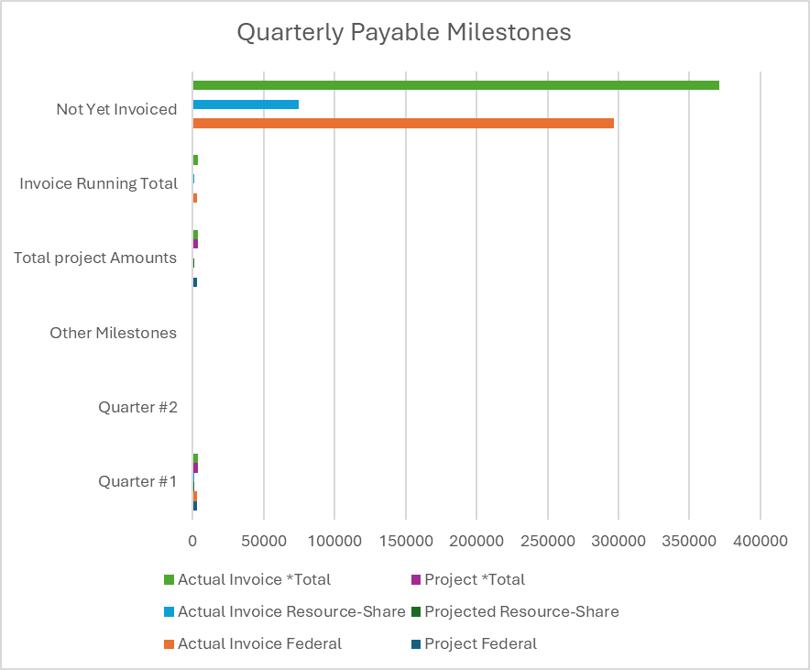

4: Project Technical Status –
We initiated our project by embarking on Task 1, which involves a thorough literature review. This review aims to amass comprehensive knowledge about the development of micro-annuli, the pathways of gas migration, and the exploration of potential techniques and solutions crucial for achieving and ensuring well integrity in Underground Natural Gas Storage (UNGS). Our review process includes an examination of issues published in recognized industry journals such as SPE (Society of Petroleum Engineers), JPT (Journal of Petroleum Technology), AADE (American Association of Drilling Engineers), and other peer-reviewed scientific journals.

In this extensive review, we focused on identifying and understanding the challenges associated with micro-annulus formations and gas leakages. Our approach encompassed examining testing methodologies, monitoring strategies, and remedial practices used in the industry. We meticulously compiled and analyzed data to compare and validate the properties and the required height of barrier materials. These materials are crucial for effectively mitigating and isolating leak paths within the annulus.

Furthermore, the evaluation of wellbore integrity is an intricate process that involves a comprehensive set of analyses. These include geological analysis, mechanical integrity tests, well logging interpretation, and surface evaluations. Effective testing for well integrity requires a clear definition of objectives and procedures, an understanding of the necessary wellbore configuration, setting precise testing objectives, and employing robust methods for analyzing results in conjunction with other pertinent data.

Importantly, this process relies on consistent and continuous interaction among various disciplines such as reservoir engineering, geology, petrophysics, and geomechanics. Given that each well is uniquely designed, there is no one-size-fits-all solution to address all issues associated with well integrity. Our literature review also extended to examining relevant publications on different components such as cements, seals, tubing, and casing integrity issues. This holistic approach allows us to gather a wide spectrum of insights and solutions that can be tailored to specific wellbore integrity challenges.

5: Project Schedule –
In the first quarter of the project, no deliverables were expected other than the quarterly report. The team is working to deliver a comprehensive literature review on zonal isolation by the end of the second quarter. It is notable that the project manager is just able to identify the appropriate postdoc candidates to help with this project, however, it is expected to finish this task on a timely basis. The PI might need 3 months extension at the end of the project to catch up with the delay in hiring the postdoc.

NOTES to Team Project Manager and delete after reading:
The Public Page of the Quarterly Report will be posted on the public project page. The Team Project Manager should include the same information from the Internal Quarterly Report in the Public Page minus any proprietary information and or data.

