**CAAP Quarterly Report**

**1/15/2024**

*Project Name: Pipeline Risk Management Using Artificial Intelligence-Enabled Modeling and Decision Making*

*Contract Number: 693JK32150001CAAP*

*Prime University: Rutgers University*

*Prepared by: Bingyan Cui (PhD student), Emad Farahani (PhD student), Dr. Hao Wang (PI), Dr. Qindan Huang (Co-PI)*

*Reporting Period: 10/1/2023 – 12/31/2023*

**Project Activities for Reporting Period:**

*Task 1 Literature Review (Completed)*

*Task 2 Data Collection from Industry Partners (Completed)*

*Task 3 Data-Driven Probabilistic Modeling of Pipeline Defects*

***Predicting Defect Growth Using Bayesian Neural Network***

The BNN is further developed to see if ensemble learning can improve model accuracy. Different from traditional machine learning methods, ensemble learning trains multiple learners simultaneously and combines their insights to address a problem. An ensemble consists of several base learners, which can be decision trees, neural networks, or other algorithms. If all base learners in an ensemble are of the same type, it's called a homogeneous ensemble, whereas an ensemble with different types of base learners is a heterogeneous ensemble. Fig. 1 provides a general framework for ensemble learning. In this figure, Model 1 to *n* represent base learners. Their predictions are combined to produce the final output. It has been observed that the predictions from an ensemble of base learners tend to be more accurate than those from individual base learners.



Fig. 1 General framework of ensemble learning.

Typical methods for combining predictions in regression problems include simple averaging, weighted averaging, stacking, and others. In this study, the simple averaging of predictions from three BNN models were used to achieve the final output.

Suppose that there is a set of *T* base learners, the average results of these leaners can be calculated as shown in Eq. (1).

 (1)

where, *H*(*x*) refers to the final output of the ensemble; *hi*(*x*) is individual results of the *i*th base learner.

The mean square error of *hi*(*x*) can be expressed as Eq. (2).

 (2)

where, *f*(*x*) represents the actual mapping function to be learned; *p*(*x*) refers to the distribution of *x*; *εi*(*x*) is the error term between *hi*(*x*) and *f*(*x*).

Thus, the average error of a single base learner can be calculated using Eq. (3).

 (3)

While the error of the whole ensemble can be determined as shown in Eq. (4).

 (4)

Based on above calculations, Eq. (5) can be then derived.

 (5)

Therefore, three BNN sub-models were established for further ensemble learning in this study, and the final predictions are the average of three sub-models. The results of ensemble BNN model for prediction of pipe corrosion defects based on the zone-based dataset from the Gulf of Mexico are presented. Fig. 2(a) and (b) show the prediction of metal loss and defect length, respectively, as compared to the measurements in the testing dataset. The epistemic error due to the uncertainty of model is plotted along with the mean value of prediction. Fig. 3(a) and (b) show the comparison of prediction (mean) vs. measurement plotted along the diagonal line for metal loss and defect length, respectively.

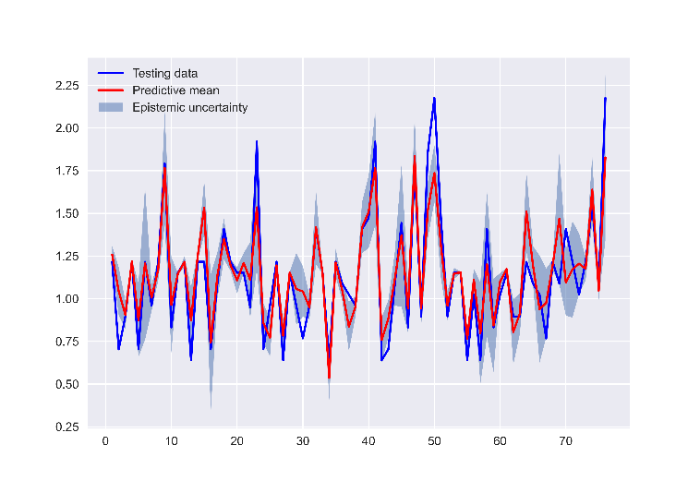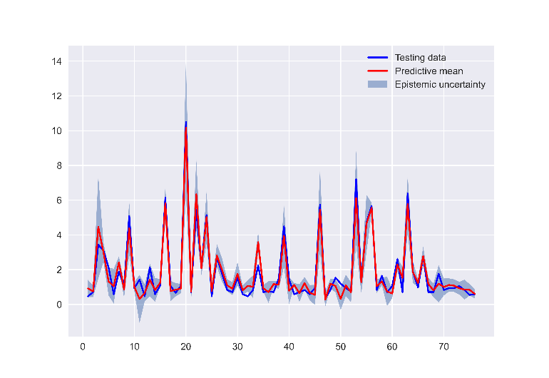

1. (b)

Fig. 2 Ensemble BNN fitting results of zone-based dataset: (a) prediction of metal loss; (b) prediction of defect length with means and epistemic error.

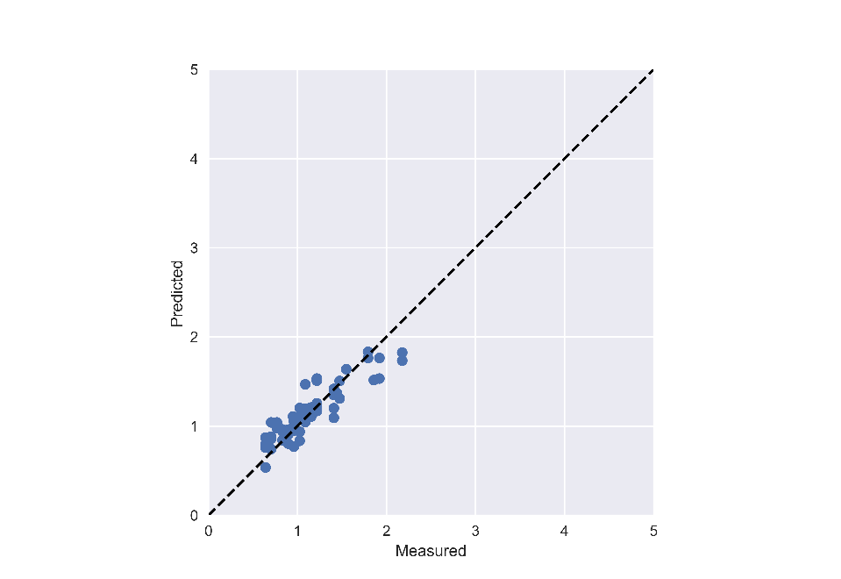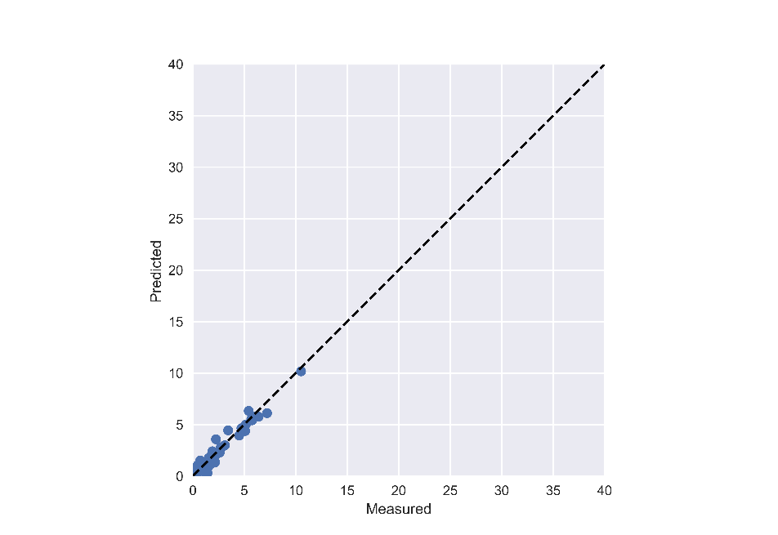

1. (b)

Fig. 3 Ensemble BNN fitting results of zone-based dataset: predicted vs. measured for (a) metal loss; (b) defect length.

Table 1 compares model accuracy in terms of R-square values for the BNN model before and after ensemble learning. The results show that ensemble learning improves prediction accuracy for metal loss but slightly affect prediction of defect length negatively. Considering the prediction accuracy for both metal loss and defect length, ensemble learning is still recommended.

Table 1. Comparison of R2 before and after using ensemble learning

|  |  |  |  |
| --- | --- | --- | --- |
| **Soil Property Input** | **Defect Type** | **BNN** | |
| **Before** | **After** |
| Zone-based dataset | Metal Loss | 0.77 | 0.802 |
| Defect Length | 0.96 | 0.947 |

***Predicting Defect Growth using Probabilistic Power Law Model***

To demonstrate the effectiveness of soil properties inclusion in growth models and also the impact of measurement error on the growth modeling, two additional sets of growth models are developed and compared with the previously developed growth models.

For the models that do not consider soil properties, growth evolution curves for external corrosion defects are compared with the ones by the previously developed models in Fig. 4. As shown in Fig. 4(b), when soil properties are not considered, the curves are only different in initiation time, i.e. the curves are similar but shifted along the time axis. When soil properties are incorporated the shape of each curve can be unique and change from one defect to another, as shown in Fig. 4(a).

|  |  |
| --- | --- |
| (a) | (b) |
| Fig. 4 Predictive corrosion depth evolution: (a) considering soil properties and no measurement error, and (b) without considering soil properties and measurement error | |

The prediction accuracy of different model sets is compared in Fig. 5 and Fig. 6, showing the scattered plots of predicted and measured corrosion defect depths and lengths, respectively. The results signify high prediction accuracy when soil properties are incorporated in model development, when comparing Fig. 5(a) and Fig. 5(b) for defect depth and comparing Fig. 6(a) and Fig. 6(b) for defect length.

(a) (b)

(c)

Fig. 5 Comparison between predicted vs. measured corrosion defect depth: (a) considering soil properties and no measurement error, (b) without considering soil properties and measurement error, and (c) considering soil properties and measurement error.

(a) (b)

(c)

Fig. 6 Comparison between predicted vs. measured corrosion defect length: (a) considering soil properties and no measurement error, (b) without considering soil properties and measurement error, and (c) considering soil properties and measurement error.

Fig. 7 further shows the effect of incorporating soil properties in the growth model in terms of defects growth path for 12 corrosion defects that all have the same measured depth of 20% of wall thickness. In this figure, black solid lines are 12 different growth paths predicted by the model when soil properties are incorporated; while red dashed line is the growth path for all 12 defects when no soil properties are considered. As discussed earlier, soil properties can differentiate the growth path between defects that have the same measured depth and lead to more accurate prediction. This inaccuracy of prediction can significantly affect the reliability of the pipeline over time and is discussed in the next section.

Fig. 7. Effect of soil properties inclusion in the prediction model on the growth of defect depth.

The effect of measurement error on prediction accuracy can be seen by comparing Fig. 5(a) and 5(c) for defect depth and comparing Fig. 6(a) and 6(c) for defect length. Previous studies have found that deeper features of corrosion defects have tendency to be oversized by the ILI. Therefore, a depth measurement error is assumed in the analysis in order to illustrate the implementation of measurement error in the proposed probabilistic framework, as shown in Fig. 8. A linearly increasing oversizing bias of zero to 10%wt for measured depths of 20%wt to 30%wt, and a constant bias of 10%wt beyond measured depth of 30%wt. Standard deviation of the depth measurement error was also considered 7.8% of wall thickness (wt) for all measurements, therefore the probability that the depth measurement error is between ±10%wt is 0.8. On the other hand, a similar linear oversizing bias was assumed for corrosion defect length measurements, as shown in Fig. 7, where the standard deviation of the length measurement error was assumed 2.34 mm such that the 80% confidence interval for length measurement error is ±3 mm.

|  |  |
| --- | --- |
|  |  |
| (a) | (b) |

Fig. 8 Considered measurement error bias in measured (a) depth and (b) length

In general, Fig. 5(c) and Fig. 6(c) demonstrate the results after considering the measurement error of ILI tools in probabilistic model development. As illustrated, considering the oversizing bias for deep and long corrosion defects leads to better prediction accuracy of models, and also uncertainty in the measurement increases total variance of the prediction.

**Project Activities with Cost Share Partners:**

Cost share is provided by Rutgers University and Marquette University during this quarterly period as budgeted in the proposal.

**Project Activities with External Partners:**

N/A

**Potential Project Risks:**

Due to additional time and effort spent on Task 2 for data collection and Task 3 for model development and refinement, one-year no-cost extension is planned to extend the project date to 9/30/2025.

**Future Project Work:**

Work will be continued on Task 4 to quantify probability of failure considering different failure modes of steel pipes and the effects of pipe repair such as composite wrap on pressure capacity of the pipe.

**Potential Impacts to Pipeline Safety:**

The ILI data will be used to develop probabilistic growth models of pipeline corrosion defects, which can aid pipeline operators better predict failure risk and make repair decisions.