Quarterly Report – Public Page

Date of Report: 10th Quarterly Report – March 31, 2023
Contract Number: #693JK32110008POTA
Prepared for: DOT and Co-funders
Project Title: Advancement of Through-tubing Casing Inspection for Underground Storage Wells
Prepared by: Pipeline Research Council International, Inc.
Contact Information: Carolyn DesCoteaux (CDescoteaux@prci.org)
For quarterly period ending: March 31, 2023

1: Items Completed During this Quarterly Period:

Item # | Task # | Activity/Deliverable | Title | Federal Cost | Cost Share
19 | 2 | Tool performance evaluation for logging test round #3 | Results to be included in the quarterly report | $31,102.24 | $31,102.24
23 | 5 | 10th quarterly status report & project management | Submit 10th quarterly report | $6,365.12 | $6,365.12

2: Items Not Completed During this Quarterly Period:

Item # | Task # | Activity/Deliverable | Title | Federal Cost | Cost Share
20 | 4 | Conduct Field Trial | Results to be included in the quarterly report | $133,990.40 | $133,990.40
22 | 3 | Final framework for reliability-based casing integrity management | Results to be included in the quarterly report | $31,206.40 | $31,206.40

3: Project Financial Tracking During this Quarterly Period:

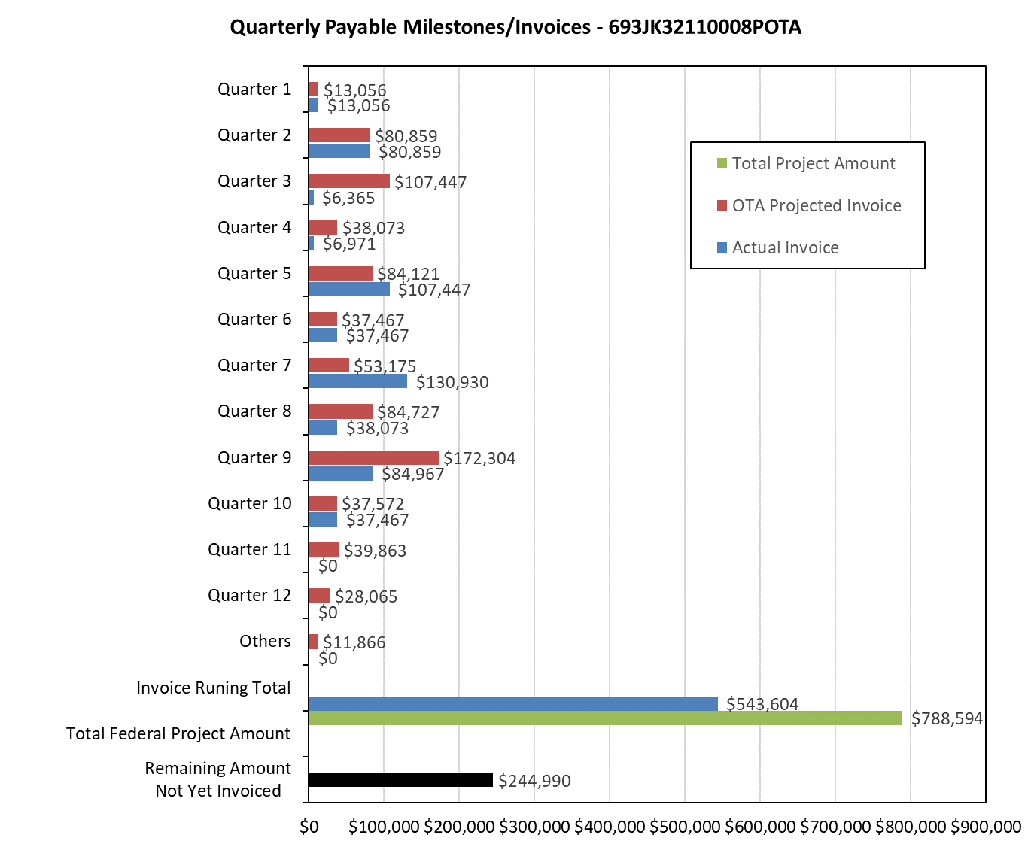

4: Project Technical Status:

[Item #19] [Task #2] [Tool performance evaluation for logging test round #3] [Results to be included in the quarterly report]

This task is complete. The tool performance evaluation was conducted based on the test reports provided by GOWell and Baker Hughes. Schlumberger was not able to participate in Round 3 of testing, therefore their tool was not included in the tool performance evaluation for Round 3.

[Item #23] [Task #5] [10th quarterly status report & project management] [Submit 8th quarterly report]

A quarterly Technical Advisory Panel (TAP) meeting was held along with the PRCI USTC meeting on February 29th, 2024. This meeting reviewed the key results of the tool performance evaluation, the overall project progress, and forecasted the work plan for the next quarter.

5: Project Schedule:

A request for a six-month no-cost project schedule extension has been submitted to PHMSA.

Anticipated schedule of delayed tasks:

[Item #20] [Task #4] [Conduct field trial] [Results to be included in the quarterly report]

The field trial is expected to be executed in Q11.

[Item #22] [Task #3] [Final framework for reliability-based casing integrity management] [Results to be included in the quarterly report]

The final framework for reliability-based casing integrity management is expected to be finalized in Q11.

