CAAP Quarterly Report 2
03/29/2024
Project Name: "Bio-Inspired Rational Design of Bio-Based Inhibitors for Mitigating Internal Corrosion in Metal Pipelines"
Contract Number: 693JK32350003CAAP
Prime University: University of Miami
Prepared By: Dr. Ali Ghahremaninezhad; a.ghahremani@miami.edu; 305-284-3465
Reporting Period: 01/01/2024-03/30/2024

Project Activities for Reporting Period:
[Include the major activities that were completed during this activity. Please describe the relevant tasks in the proposal that have been completed or status of their process]
Student recruitment: One Ph.D. student named Sevil Ozsut has been recruited, who will be involved in various tasks/activities including literature review, experiment design and implementation, and data analysis.
Work focused on the investigation of the inhibitory activity of several amino acids on mild steel in acidic environments. The efficiency of the inhibitors was assessed by gravimetric mass loss measurement and electrochemical measurements. Open circuit potential (OCP), potentiodynamic polarization measurements (PDP), and electrochemical impedance spectroscopy (EIS) were used as electrochemical measurement techniques. In this report, the used materials, conducted experiments, and their results are presented.

Experimental

Materials
Tests were performed on a mild steel specimen of the percentage composition C: 0.059, Si: 0.18, Mn: 0.4610, P: 0.01, S:0.011, and the rest of Fe. The steel bar was purchased from McMaster-Carr, US. The specimens of size 10mm x 10mm x 2mm were cut from the mild steel bar. Before both the gravimetric and the electrochemical tests, the specimens’ surfaces were physically polished with silicon carbide (SiC) paper ranging from grade #180 to #600 for the test of L-Arginine, L-Glutamic Acid, L-Threonine, and from grade #180 to #1200 for the test of L-Methionine. This was followed by rinsing with distilled water, degreased with acetone, and finally dried in air. Before any experiment, the substrates were treated as described and freshly used with no further storage.
The reagent grade (≥ 98%) amino acids (L-Methionine, L-Arginine, L-Glutamic Acid, and L-Threonine) and concentrated HCl (37%) were purchased from Sigma-Aldrich. The amino acids were used as an inhibitor with no further purification. The molecular structures of the amino acids are presented in Figure 1. The electrolytic solution of 0.5M HCl was prepared from dilution of 37% analytical grade HCl. The test inhibitors were dissolved in 0.5 M HCl to obtain the desired concentration (0.002% – 0.02% wt).
 | 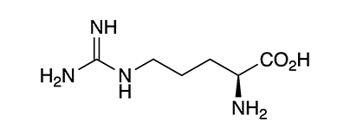 | 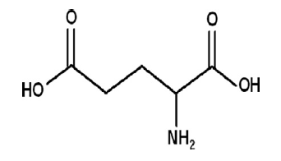 | 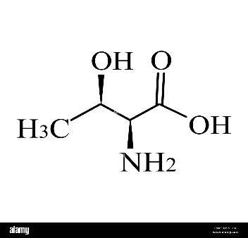
L-Methionine | L-Arginine | L-Glutamic Acid | L-Threonine
Figure 1: Molecular structure of used amino acids.

Gravimetric Measurements
The mild-steel coupons with almost equal sizes and masses were used to determine the inhibition efficiency via gravimetric mass-loss measurements. The weight loss was measured as the difference between the weight at a given time and the initial weight of the specimens. Mild steel coupons (10mm x 10mm x 2mm) were immersed in 0.5 M HCl for 24 h in the absence and presence of amino acid inhibitors with different concentrations of 0.002% to 0.02% wt. Then, the steel coupons were rinsed with acetone, dried in air, and reweighted. The average relative mass loss of the mild-steel coupons was determined from three individual measurements. All the measurements were taken at room temperature. The corrosion rate (CR) and inhibition efficiency (IE) were calculated by the following equations:
$$\text{CR} \left(\text{mmy}\right)\text{=}\frac{\text{KW}}{\text{ρAt}}$$ | (1)
where W is the weight loss (in g), $\text{ρ}$ is the density (gcm⁻³), A is the exposed area of the specimen (cm), and t is the exposure time ( h). K is a constant that can be varied to calculate the corrosion rate in various units. For the case of mm/year for corrosion rate calculation, K is equal to 8.75x10⁴.
$${\text{IE}}_{\text{WL}}\left(\text{\%}\right)\text{=}\frac{{\text{CR}}_{\text{0}}\text{-}{\text{CR}}_{\text{i}}}{{\text{CR}}_{\text{0}}}\text{ x 100}$$ | (2)
where ${\text{CR}}_{\text{0}}$ and ${\text{CR}}_{\text{i}}$ are the corrosion rate of mild steel in the absence and presence of inhibitor respectively.

Electrochemical Measurements
Electrochemical experiments were conducted in a conventional three-electrode glass cell, using a Gamry Reference 600 potentiostat. Mild steel coupons were used as the working electrode. The saturated calomel electrode (SCE) and platinum sheet electrode were used as reference electrode and counter electrode, respectively. Before carrying out the electrochemical tests, the working electrode was immersed in electrolytic solution for 30 minutes to ensure that there is a steady-state potential on the electrode surface. The open circuit potential (OCP) of the corroding system was monitored for 30 minutes to ensure a steady-state condition. In this work, all the electrochemical experiments were repeated three times to examine the reproducibility of the electrochemical data.
Electrochemical impedance spectroscopy (EIS) was conducted at corrosion potentials (Ecorr) over a frequency range of 100 kHz–10 MHz, with amplitude signal of 10 mV acquiring 10 points/decade. The obtained EIS data were interpreted with Gamry Echem Analyst. With EIS results, the corrosion inhibition efficiency was obtained according to Equation 3.
$${\text{IE}}_{\text{EIS}}\left(\text{\%}\right)\text{=}\frac{{\text{R}}_{\text{ct}}\text{-}{\text{R}}_{\text{ct,0}}}{{\text{R}}_{\text{ct}}}\text{ x 100}$$ | (3)
where ${\text{R}}_{\text{ct,0}}$ and ${\text{R}}_{\text{ct}}$are the charge transfer resistance without and with inhibitor, respectively.
The potentiodynamic polarization (PDP) curves were carried out under the potential from −250 mV to +250 mV vs. OCP at a scan rate of 0.5 mV/s. The PDP test was conducted only for the L-Methionine test series. The inhibition efficiency was calculated from the measured Icorr values using the relationship:
$${\text{IE}}_{\text{PDP}}\left(\text{\%}\right)\text{=}\frac{{\text{I}}_{\text{corr,0}}\text{-}{\text{I}}_{\text{corr}}}{{\text{I}}_{\text{corr,0}}}\text{ x 100}$$ | (4)
where ${\text{I}}_{\text{corr,0}}$ and ${\text{I}}_{\text{corr}}$ are the corrosion current density without and with inhibitor, respectively.

Results and discussion

Gravimetric Measurements
The corrosion behavior of mild steel in 0.5 M HCl in the absence and presence of different concentrations of amino acids was studied using a weight loss technique and data obtained after 24 h of immersion are shown in Table 1 . The corrosion rate of mild steel is reduced in the presence of inhibitors as compared to free acid solution and depends upon the used inhibitor concentration. For all amino acids tested, the IE increases with increasing concentration of inhibitor.
For Methionine, IE reached its maximum of 80.75% at the concentration of 0.02%wt. The increased IE with increasing inhibitor concentrations indicates that more L-Methionine molecules are adsorbed on the steel surface at higher concentrations, leading to greater surface coverage and hence the formation of a protective film (Mobin et al., 2017). Arginine has shown similar behavior with Methionine in terms of concentration-based increase in IE, and the maximum IE of 80.21% was obtained at the concentration of 0.02%wt.
On the other hand, Glutamic Acid had a higher value for the corrosion rate than that of the control sample for its all-concentration level. Therefore, the negative values of IE showed that the presence of Glutamic Acid could not inhibit the corrosion of mild steel in 0.5 M HCl solution. On the contrary, Glutamic Acid could accelerate the corrosion. However, the value of IE has increased with increasing concentration. This indicates that as the concentration of inhibitor is increased the covered steel surface by inhibitor molecules increases (Ashassi-Sorkhabi et al., 2004).
The corrosion rate value decreased with increasing concentration of Threonine. In terms of IE, Threonine showed mitigation of corrosion for mild steel in 0.5 M HCl for the highest concentration (0.02%wt). The photos taken before and after the immersion of the Threonine test samples were provided in Figure 2.

Table 1: The weight loss parameters obtained for mild steel in 0.5M HCl solution without and with various concentrations of amino acids.
Amino Acid | Concentration (%wt) | Corrosion Rate (mm/year) | Inhibition Efficiency (%)
Control¹ | 0 | 10.91 | -
L-Methionine | 0.002 | 9.96 | 8.73
 | 0.008 | 2.13 | 80.48
 | 0.02 | 2.10 | 80.75
L-Arginine | 0.002 | 10.78 | 1.12
 | 0.008 | 2.19 | 79.88
 | 0.02 | 2.16 | 80.21
Control² | 0 | 9.33 | -
L-Glutamic Acid | 0.002 | 10.21 | -9.44
 | 0.008 | 9.82 | -5.30
 | 0.02 | 9.40 | -0.82
L-Threonine | 0.002 | 10.57 | -13.30
 | 0.008 | 9.90 | -6.17
 | 0.02 | 8.71 | 6.62
Control¹: Control sample for test series of L-Methionine and L-Arginine
Control²: Control sample for test series of L-Glutamic Acid and L-Threonine
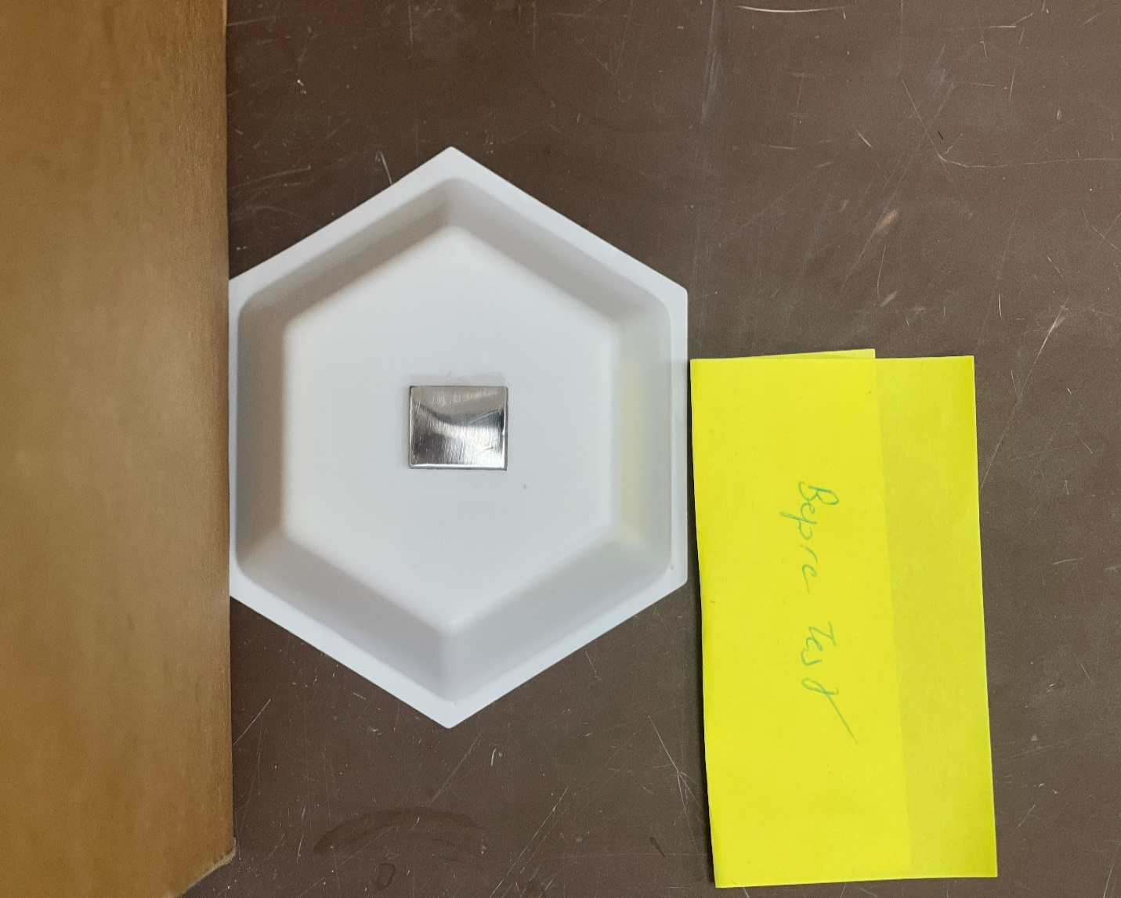 | 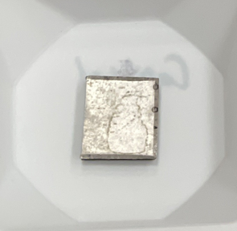 | 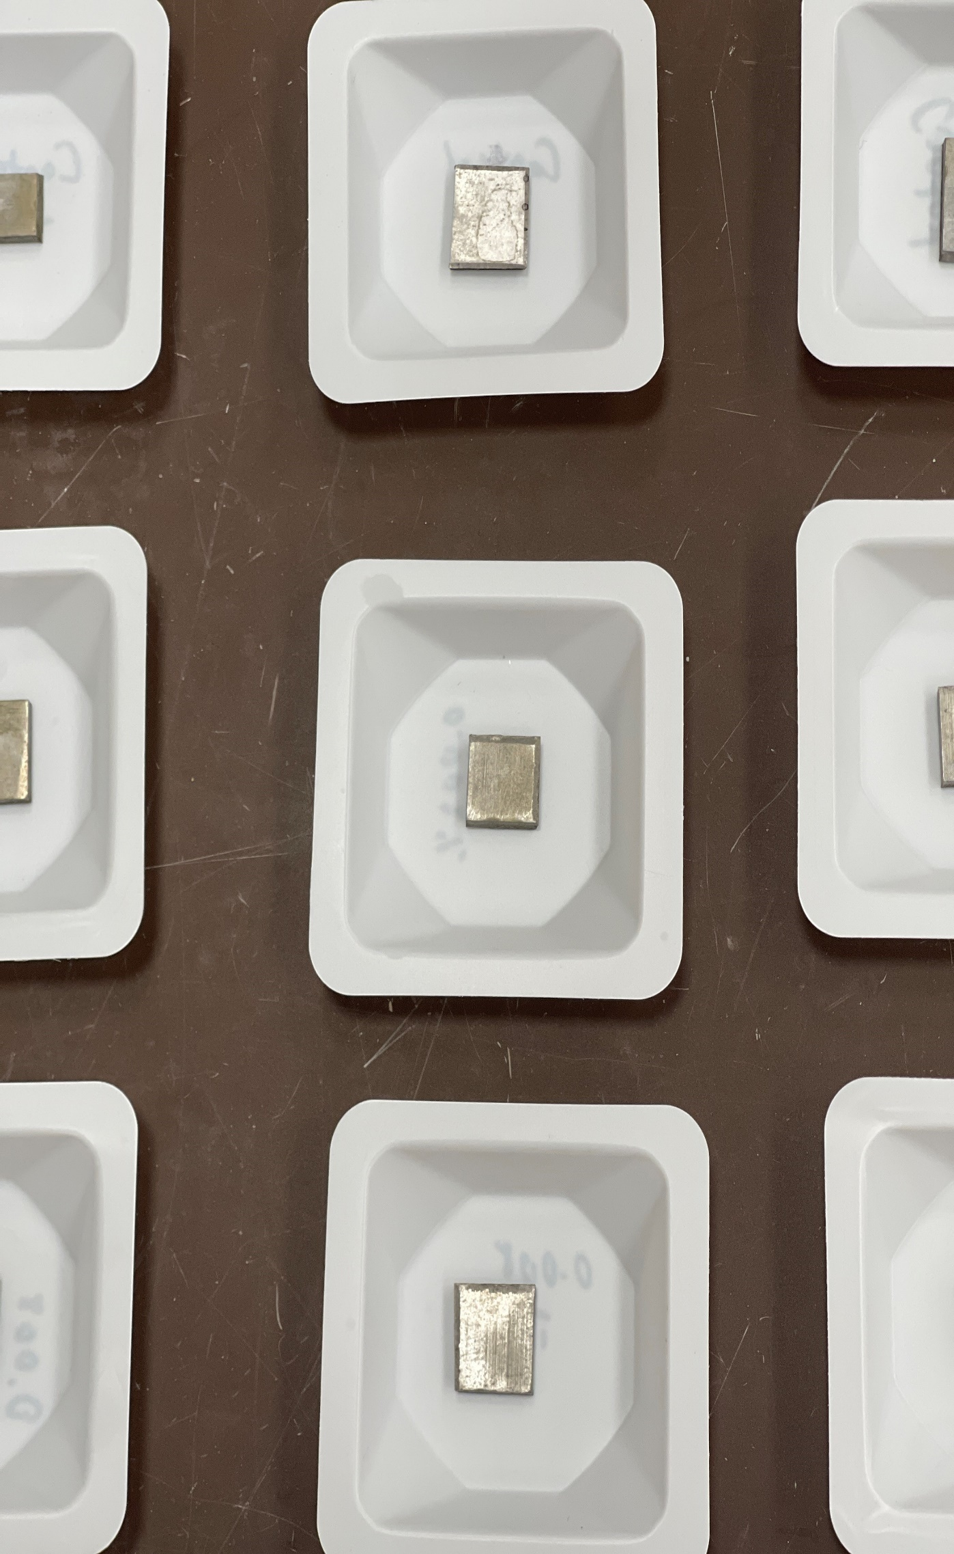 | 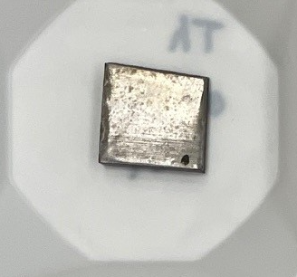 | 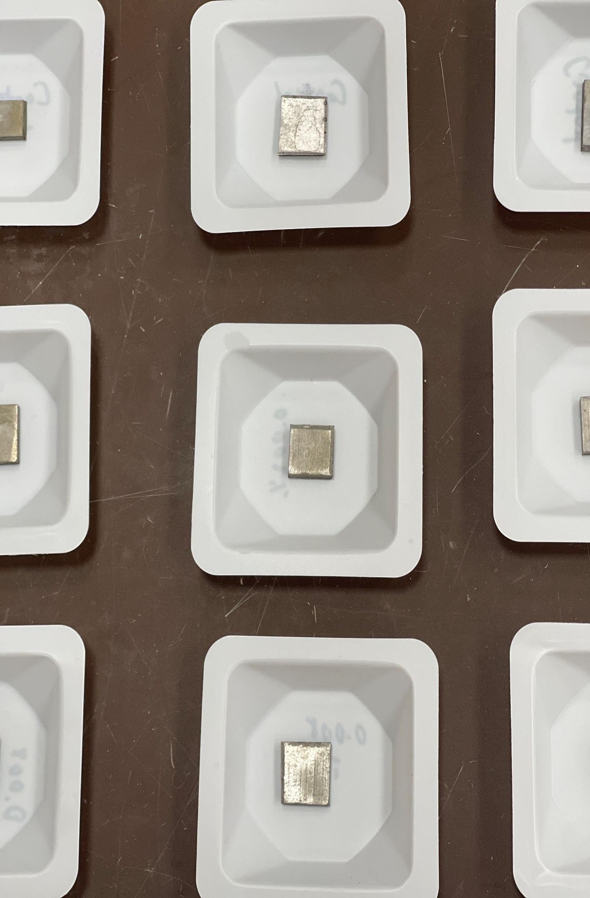
Before test | Control | 0.002% | 0.008% | 0.02%
Figure 2: Mild steel samples tested for weight loss measurement before and after the test in 0.5M HCl with different concentrations of L-Threonine

Electrochemical Measurements
- Electrochemical impedance spectroscopy (EIS)
Electrochemical impedance spectroscopy is a powerful technique used for the analysis of interfacial properties related to corrosion events occurring at the electrode surface. Therefore, the corrosion and inhibition processes were also investigated by the EIS analysis in this work. Figure 3 displays the obtained Nyquist plots, Bode, and phase angle plots for mild steel electrode without and with the Methionine as an inhibitor at the various concentrations.
It is noted that all obtained Nyquist curves for both uninhibited and Methionine-inhibited systems were depressed semi-circles, showing that the charge-transfer mechanism controls the reaction processes (Guo et al., 2022). In Nyquist plots, the intercept of the loops on the horizontal axis and the diameter of the capacitive loop represents the charge transfer resistance (R_{ct}). A larger R_{ct} indicates a stronger resistance to corrosion. As illustrated in Figure 2 (a), the diameters of the Nyquist semicircles increased with increasing Methionine concentration. This indicates that charge transfer resistance (R_{ct}) increases with increasing inhibitor concentration. This phenomenon can be defined as the inhibited system showing resistance to corrosion current flow with an increase in Methionine concentrations. In other words, attracting the Methionine to the metal surface makes migration of charge to the electrode surface more difficult (Wang et al., 2023).
To further analyze the obtained impedance data, Bode plots were developed. The Modulus plot in Figure 2 (b) showed that the value of impedance modulus (|Z|) increases with increasing Methionine concentration, which indicates that the adsorption of Methionine inhibits the corrosion of steel in HCl solution (Guo et al., 2022). Having higher absolute impedance values at higher concentrations resulted from the alteration of the double layer on the metal surface due to the adsorption of Methionine molecules by forming metal complexes (Udayappan & Veawab, 2022).
It was also shown in Figure 2 (c) that values of maximum phase angle for Methionine-inhibited specimens increased with concentration of inhibitor. Moreover, the obtained values for the inhibited case were higher than those for the uninhibited specimens with a single time constant. The presence of a single time constant for the Phase angle plot suggests that there is a dominant relaxation process occurring in the system. This could indicate the kinetics of the corrosion and inhibition processes on the working electrode. Also, this shows that the metal surface became appreciably smooth owing to the formation of a protective film by the inhibitor over the metal surface (Verma et al., 2017).

(a) | 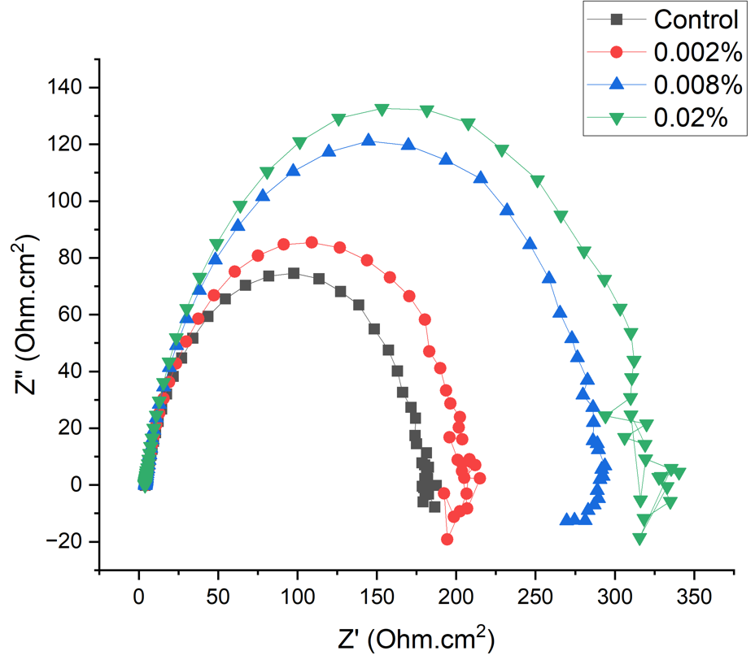
(b) | 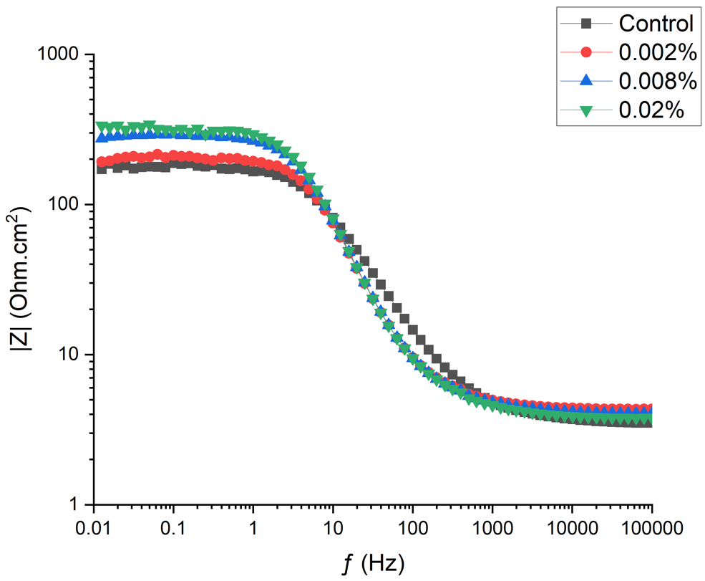
(c) | 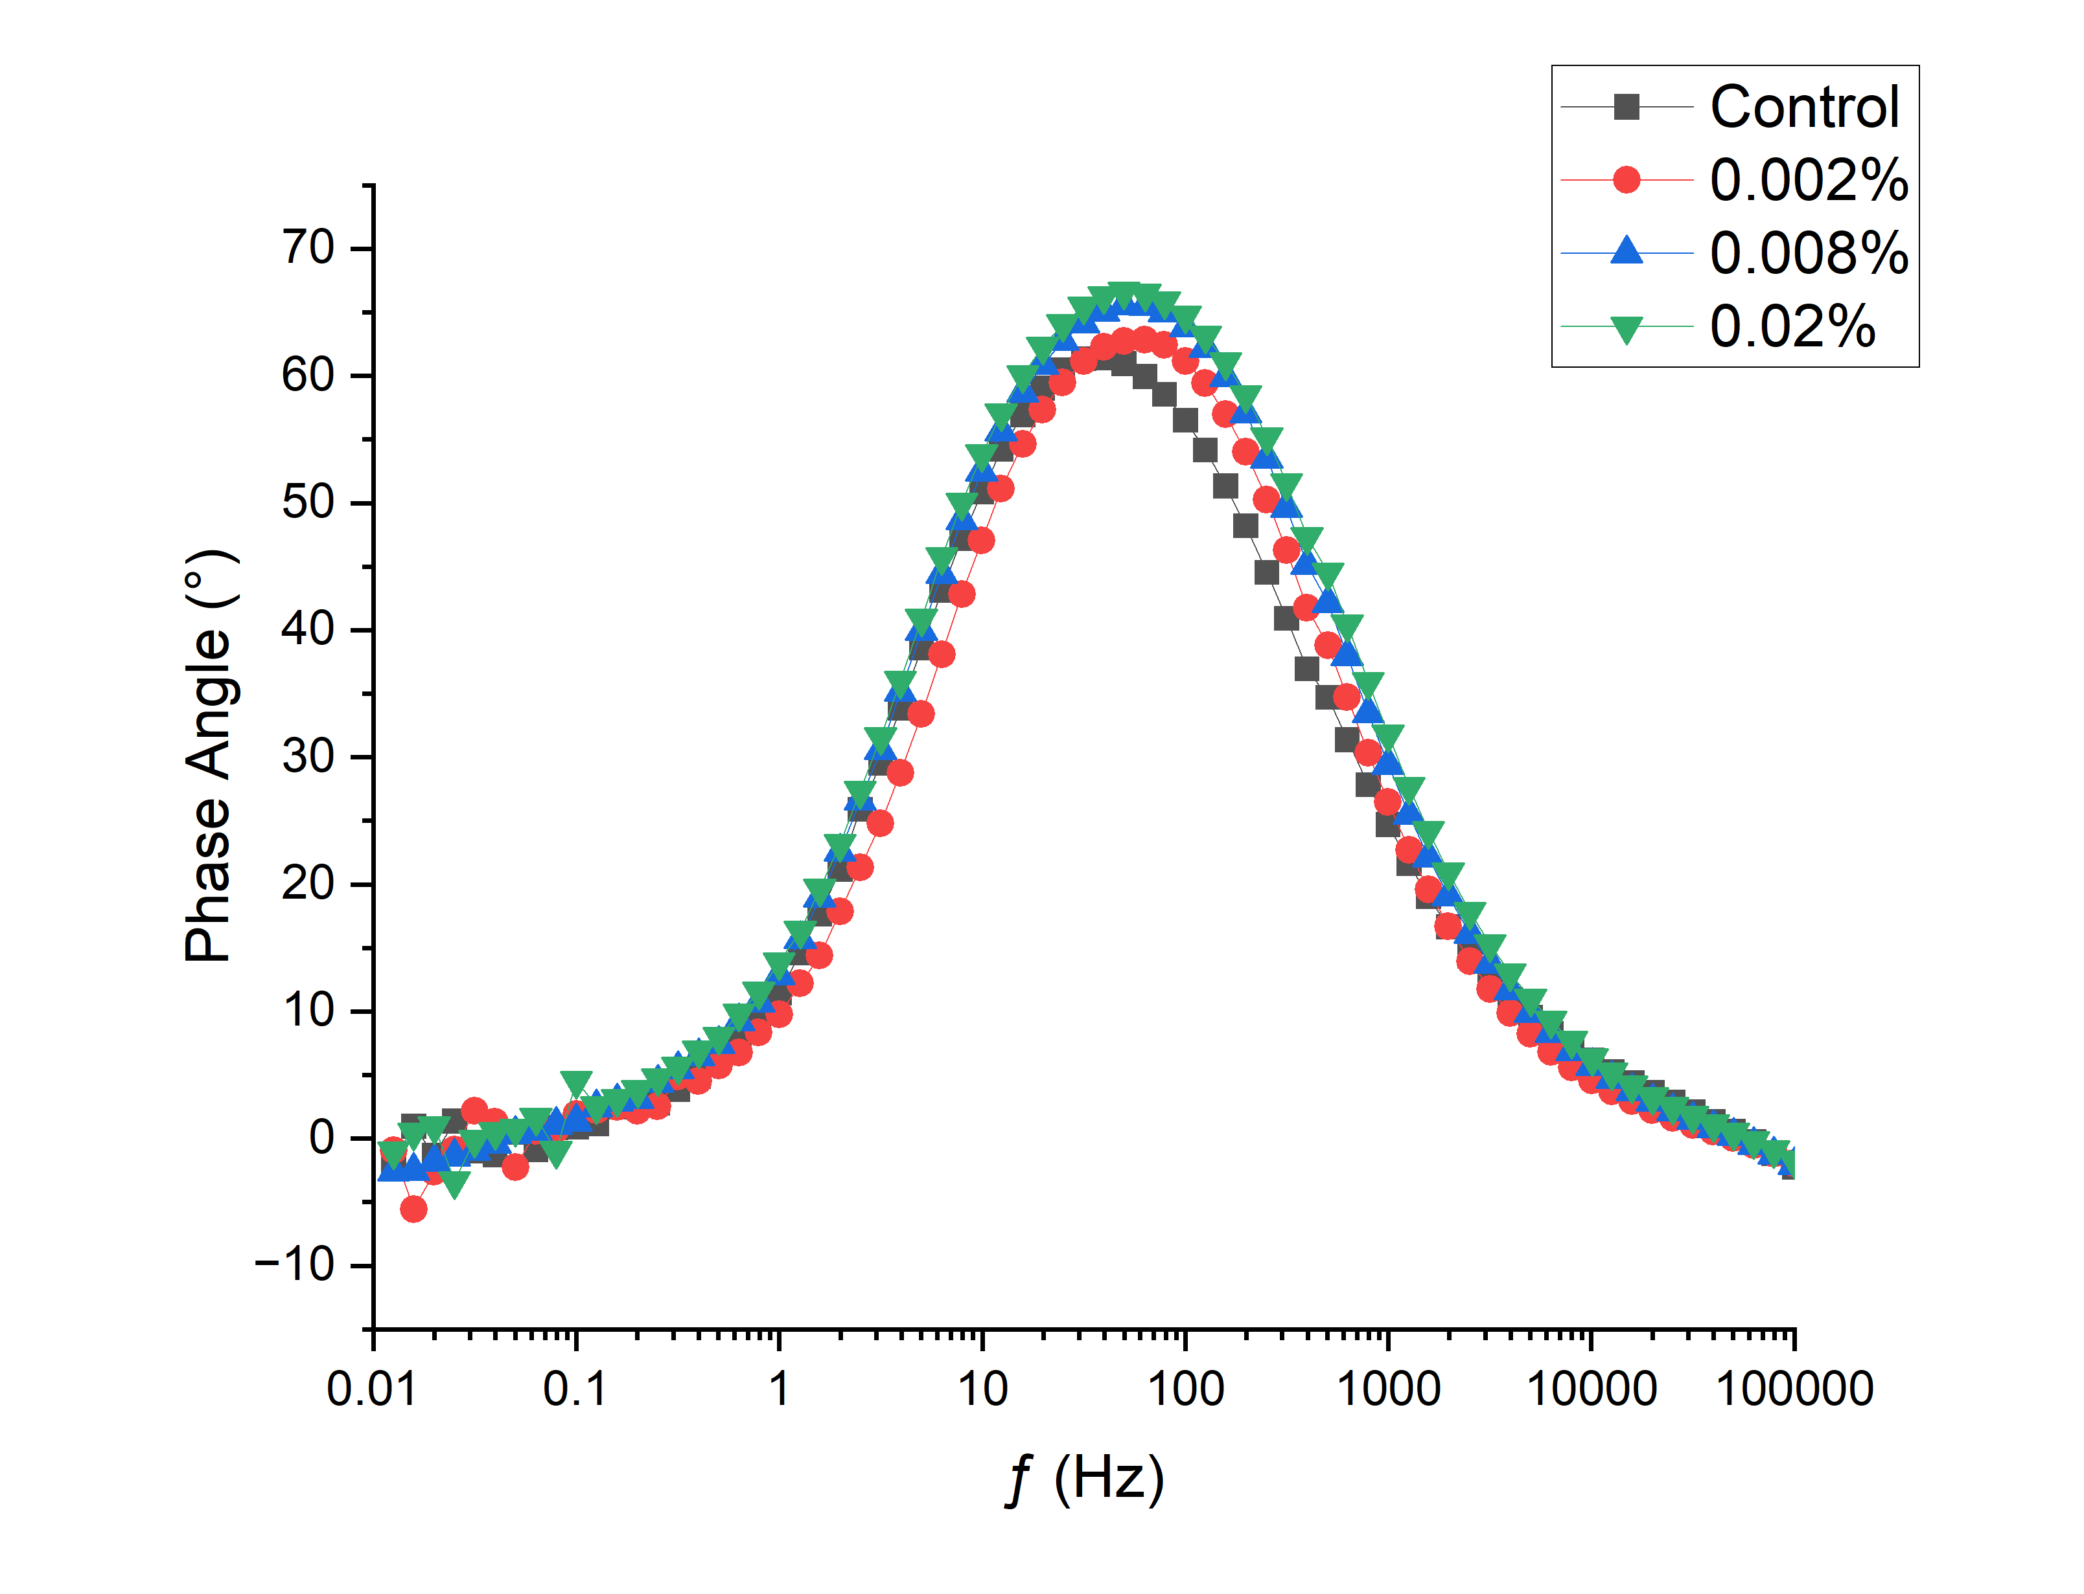
Figure 3: (a) Nyquist, (b) Bode plots, and (c) Phase angle plots for mild steel in 0.5M HCl with different concentrations of L-Methionine
In Figure 4, the Nyquist plots were presented for the mild steel in 0.5 M HCl without and with Glutamic Acid as an inhibitor at different concentrations. It was observed from the plot that the R_{ct} values for all concentrations of Glutamic Acid were lower than the control sample. This indicates that Glutamic Acid does not provide any effect towards inhibiting the corrosion of mild steel in 0.5 M HCl; rather its presence marginally enhances the rate of corrosion of mild steel in 0.5 M HCl. This can be linked with an increase in the rate of cathodic reduction reaction, as the anodic reaction pathway remains unperturbed. The interionic interactions in the aqueous acid solution in the presence of amino acid result in an increase in the rate of the cathodic reduction reaction. There are H⁺ and Cl⁻ ions present in hydrated ion-pair form in the aqueous HCl solution. When Glutamic Acid is added to the HCl solution, it takes up a proton from the solution and becomes cationic form. The cationic Glutamic Acid has a larger dipole moment than water. So, water dipoles reorient themselves along cationic Glutamic Acid. This phenomenon leads to more diffusible H⁺ ions in the aqueous solution. Thus, more H⁺ ions can be diffused toward cathodic reaction sites per unit of time, resulting in an overall increase in the corrosion rate of mild steel in acid medium (Roy et al., 2017).
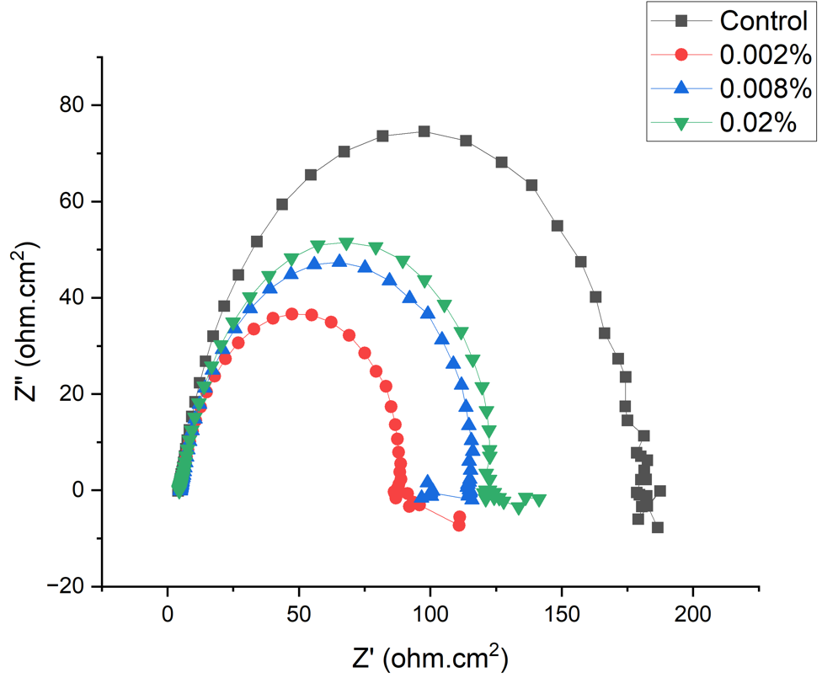
Figure 4: Nyquist plots for mild steel in 0.5M HCl with different concentrations of L-Glutamic Acid
The measured impedance data for all amino acids used as inhibitors is listed in Table 2. The obtained results in EIS were analyzed using an electrical equivalent circuit as shown in Figure 5. In this circuit, R_{S} is the solution resistance between the reference and the working electrodes, R_{ct} represents the charge-transfer resistance at the metal-electrolyte interface, and CPE is the constant phase element. The use of CPE instead of double-layer capacitance (Cdl) could be linked to compensate for the deviation from the ideal dielectric behavior caused by the inhomogeneous nature of the electrode surface (Guo et al., 2022). The impedance function of CPE can be described by the equation:
$${\text{Z}}_{\text{CPE}}\text{=}{\text{Y}}_{\text{0}}^{\text{-1}}{\text{(jω)}}^{\text{-n}}$$ | (5)
where ${\text{Y}}_{\text{0}}$ is the magnitude of the CPE, j is an imaginary number ${\text{(j}}^{\text{2}}\text{ = -1)}$, $\text{ω}$ is the angular frequency (=2πƒ) and exponent $n$ is the deviation parameter and has values among -1 to 1. Based on the values of $n$, the CPE can represent: inductance (n = -1), resistance (n = 0), Warburg impedance (n = 0.5) ,and capacitance (n = 1); n is a measure of surface irregularity (Farag et al., 2018). The double layer capacitance (${\text{C}}_{\text{dl}})$ can be obtained by equation:
$${\text{C}}_{\text{dl}}\text{=}{\text{Y}}_{\text{0}}{\text{(}{\text{ω}}_{\text{max}}\text{)}}^{\text{n-1}}\text{= }{\text{Y}}_{\text{0}}{\text{(2π}{\text{ƒ}}_{{\text{Z}}_{\text{im-max}}}\text{)}}^{\text{n-1}}$$ | (6)
where ${\text{ω}}_{\text{max}}$ is the frequency at which the imaginary impedance has the highest value.
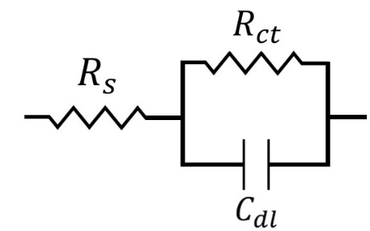
Figure 5: Electrochemical equivalent circuit used to fit the impedance spectra.
From Table 2, it was observed that there was significant enhancement in the change of R_{ct} when L-Methionine and L-Arginine were added to the acid solution. An increase in the R_{ct} manifests the formation of a protective layer on the metal surface, which provides higher resistance toward charge transfer reactions occurring at the metal-electrolyte interface region (Satpati et al., 2020). The obtained R_{ct} allowed to calculate their efficiency in terms of inhibition of corrosion. Both Methionine and Arginine showed positive effects for corrosion inhibition. Furthermore, decrease in double-layer capacitance (C_{dl}) with inhibitor concentration can be explained in terms of the adsorption of inhibitor molecules on the metal surface by replacing pre-adsorbed water molecules, thus increasing the thickness of the inhibitive layer. Those inhibitors have the potential of efficient resistive layer formation, and thereby provide higher resistance to the electrochemical corrosion reaction (Amin et al., 2010).

Table 2: EIS parameters for mild steel in 0.5 M HCl and the presence of different concentrations of the investigated inhibitors.
Amino Acid | Conc. (%wt) | R_{s} (Ohm.cm²) | CPE |  |  | $C_{dl}$ (μFcm⁻²) | R_{ct} (Ohm.cm²) | IE (%)
 |  |  | $Y_{0}$(Ss^{n}cm⁻²) x 10⁻⁶ |  | $$n$$
Control¹ | 0 | 4.329 | 319.6 | 0.842 |  | 185.33 | 187.67 | -
L-Methionine | 0.002 | 4.368 | 191.8 | 0.874 |  | 120.97 | 197.53 | 5.0
 | 0.008 | 4.105 | 178.2 | 0.871 |  | 114.21 | 282.99 | 33.7
 | 0.02 | 3.848 | 172.00 | 0.869 |  | 109.59 | 317.35 | 40.9
Control² | 0 | 4.344 | 301.2 | 0.860 |  | 185.59 | 179.80 | -
L-Arginine | 0.002 | 4.725 | 338.6 | 0.869 |  | 222.70 | 181.5 | 0.9
 | 0.008 | 4.885 | 239.93 | 0.862 |  | 147.40 | 184.46 | 2.5
 | 0.02 | 4.241 | 200.37 | 0.861 |  | 128.49 | 282.97 | 36.4
L-Glutamic Acid | 0.002 | 4.771 | 308.87 | 0.859 |  | 249.27 | 80.95 | -116.7
 | 0.008 | 5.010 | 302.73 | 0.881 |  | 190.84 | 108.13 | -62.2
 | 0.02 | 4.592 | 409.7 | 0.878 |  | 187.74 | 118.38 | -48.2
L-Threonine | 0.002 | 4.658 | 421.7 | 0.853 |  | 245.47 | 85.07 | -106.2
 | 0.008 | 4.989 | 261.90 | 0.881 |  | 171.61 | 165.51 | -6.0
 | 0.02 | 4.976 | 261.73 | 0.852 |  | 149.42 | 178.23 | 1.6
Control¹: Control samples polished with SiC paper up to #1200
Control²: Control samples polished with SiC paper up to #600
On the contrary, the results for L-Glutamic Acid and Threonine showed that the presence of these amino acids in the solution reduced the charge transfer resistance (R_{ct}) even at the small concentration. For the Glutamic Acid and Threonine, R_{ct} values were reduced from 179.80 ohm.cm² in without inhibitor to 80.95 and 85.07 ohm.cm² in concentration of 0.002% wt of the inhibitors respectively. Thus, it may be concluded that both Glutamic Acid and Threonine cannot impede the interfacial corrosion reaction of mild steel in 0.5 M HCl by forming any resistive layer on the metal surface. This indicates that those amino acids stimulate the corrosion reaction (Oguzie et al., 2007). However, as the concentration of both inhibitors increased the value of charge transfer resistance also increased. Moreover, the C_{dl} values decreased with increasing concentration, which suggests that Glutamic Acid and Threonine were adsorbed on the electrode surface at all concentrations (Oguzie et al., 2007).
The increase in C_{dl} values, for comparison of control and Glutamic Acid / Threonine treated cases, may be considered in terms of the Helmholtz model:
$${\text{C}}_{\text{dl}}\text{=}\frac{{\text{ε}}_{\text{0}}\text{ε}}{\text{d}}\text{A}$$ | (6)
where A is an area of the electrode surface, d is the thickness of the protective layer, ${\text{ε}}_{\text{0}}$is the permittivity of air and ε is the local dielectric constant. It can be suggested that the presence of Glutamic Acid or Threonine at the Fe/solution interface rendered the Fe surface more electrochemically active, probably diminishing the stability and thickness of the protective layer of reaction products on the electrode surface (Mobin et al., 2017; Oguzie et al., 2007).
To conclude, the experimental descending order of the corrosion inhibitor for mild steel in 0.5M HCl was Methionine > Arginine > Threonine > Glutamic Acid.
- Potentiodynamic polarization (PDP)
Potentiodynamic polarization curves for the corrosion of mild steel in 0.5 M HCl in the absence and presence of L-Methionine was shown in Figure 6. The electrochemical parameters which are corrosion potential (E_{corr}), corrosion current density (i_{corr}), and % IE_{PDP} were deduced from these curves, and they were presented in Table 3.
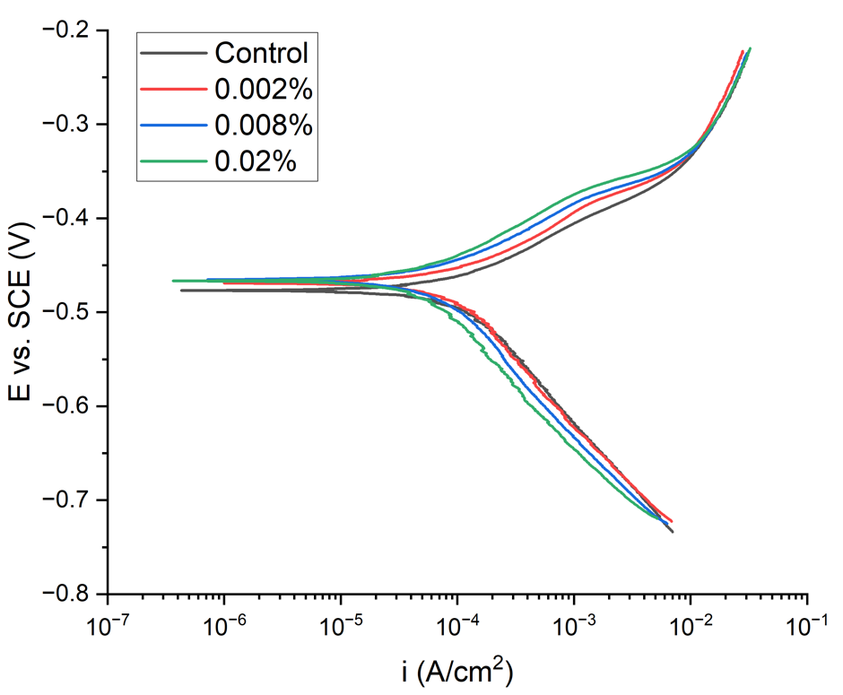
Figure 6: Potentiodynamic curves for mild steel in 0.5 M HCl in the absence and presence of various concentrations of L-Methionine
Table 3: Tafel polarization parameters and corresponding inhibition efficiencies for the corrosion of mild steel in 0.5 M HCl without and with addition of various concentrations of L-Methionine
Concentration (%wt) | I_{corr} (μA/cm²) | E_{corr} (mV) | β_{a} (mV/dec) | -β_{c} (mV/dec) | Corrosion Rate (mpy) | IE_{PDP} (%)
Control | 121.5 | -477.5 | 71.5 | 149.3 | 55.5 | -
0.002 | 111.0 | -469.0 | 73.6 | 166.8 | 50.72 | 8.6
0.008 | 79.2 | -465.0 | 71.3 | 162.3 | 36.2 | 34.8
0.02 | 69.3 | -467.0 | 79.4 | 175.4 | 31.66 | 42.9
It was observed that the addition of Methionine reduced the rates of both the cathodic hydrogen evolution and the anodic Fe dissolution. The decrease in I_{corr} values and corrosion rate with increase in methionine concentration indicates that the presence of Methionine in acidic media mitigates the corrosion on the metal. The values of E_{corr} in the presence of Methionine shift to more positive values compared to the control. The positive shift in E_{corr} was more pronounced for the higher concentration of Methionine. This phenomenon suggests that using Methionine as an inhibitor in acidic media has the dominant role of anodic suppression in the process (Hu et al., 2010). As the change in E_{corr} value for uninhibited and Methionine inhibited solutions were less than 85 mV in all test conditions, Methionine could be considered as a mixed-type corrosion inhibitor (Udayappan & Veawab, 2022). All the results obtained by electrochemical studies are consistent with the results of the weight loss measurements for all types of inhibitors with all tested concentrations.

Conclusions
The effect of selected inhibitors, L-Methionine, L-Arginine, L-Glutamic Acid, and L-Threonine on mild steel in 0.5 M HCl was investigated by gravimetric mass loss measurement and electrochemical measurements. The obtained results showed that L-Methionine and L-Arginine were effective corrosion inhibitors for mild steel in 0.5 M HCl. With the increasing Methionine and Arginine concentration in the solution, corrosion inhibition rate also increased. The data obtained from weight loss measurements and electrochemical measurements were consistent for each test.
On the contrary, L-Glutamic Acid and L-Threonine showed negative effect in terms of corrosion inhibition of mild steel. These inhibitors were found to accelerate the mild steel corrosion at low concentrations. However, as the concentration of the inhibitors increased, the value of C_{dl} decreased, suggesting adsorption of the amino acids on the electrode surface increased.

References
Amin, M. A., Khaled, K. F., Mohsen, Q., & Arida, H. A. (2010). A study of the inhibition of iron corrosion in HCl solutions by some amino acids. Corrosion Science, 52(5), 1684–1695. https://doi.org/10.1016/j.corsci.2010.01.019
Ashassi-Sorkhabi, H., Majidi, M. R., & Seyyedi, K. (2004). Investigation of inhibition effect of some amino acids against steel corrosion in HCl solution. Applied Surface Science, 225(1–4), 176–185. https://doi.org/10.1016/j.apsusc.2003.10.007
Farag, A. A., Ismail, A. S., & Migahed, M. A. (2018). Environmental-friendly shrimp waste protein corrosion inhibitor for carbon steel in 1 M HCl solution. Egyptian Journal of Petroleum, 27(4), 1187–1194. https://doi.org/10.1016/j.ejpe.2018.05.001
Guo, L., Luo, Y., Huang, Y., Yang, W., Zheng, X., Lin, Y., & Marzouki, R. (2022). Imidazolidiny Urea as a Potential Corrosion Inhibitor for Mild Steel in HCl Medium: Experimental and Density-Functional Based Tight-Binding Methods. International Journal of Electrochemical Science, 17(7), 220748. https://doi.org/10.20964/2022.07.34
Hu, L., Zhang, S., Li, W., & Hou, B. (2010). Electrochemical and thermodynamic investigation of diniconazole and triadimefon as corrosion inhibitors for copper in synthetic seawater. Corrosion Science, 52(9), 2891–2896. https://doi.org/10.1016/j.corsci.2010.04.038
Mobin, M., Parveen, M., & Rafiquee, M. Z. A. (2017). Synergistic effect of sodium dodecyl sulfate and cetyltrimethyl ammonium bromide on the corrosion inhibition behavior of l -methionine on mild steel in acidic medium. Arabian Journal of Chemistry, 10, S1364–S1372. https://doi.org/10.1016/j.arabjc.2013.04.006
Oguzie, E. E., Li, Y., & Wang, F. H. (2007). Effect of 2-amino-3-mercaptopropanoic acid (cysteine) on the corrosion behaviour of low carbon steel in sulphuric acid. Electrochimica Acta, 53(2), 909–914. https://doi.org/10.1016/j.electacta.2007.07.076
Roy, P., Saha, S. Kr., Banerjee, P., Dey, S., & Sukul, D. (2017). Experimental and theoretical investigation towards anti-corrosive property of glutamic acid and poly-γ-glutamic acid for mild steel in 1 M HCl: Intramolecular synergism due to copolymerization. Research on Chemical Intermediates, 43(8), 4423–4444. https://doi.org/10.1007/s11164-017-2887-6
Satpati, S., Saha, S. Kr., Suhasaria, A., Banerjee, P., & Sukul, D. (2020). Adsorption and anti-corrosion characteristics of vanillin Schiff bases on mild steel in 1 M HCl: Experimental and theoretical study. RSC Advances, 10(16), 9258–9273. https://doi.org/10.1039/C9RA07982C
Udayappan, B., & Veawab, A. (2022). Performance analysis of methionine as an environmentally friendly corrosion inhibitor for carbon steel in the amine based carbon capture process. International Journal of Greenhouse Gas Control, 114, 103565. https://doi.org/10.1016/j.ijggc.2021.103565
Verma, C., Quraishi, M. A., Kluza, K., Makowska-Janusik, M., Olasunkanmi, L. O., & Ebenso, E. E. (2017). Corrosion inhibition of mild steel in 1M HCl by D-glucose derivatives of dihydropyrido [2,3-d:6,5-d′] dipyrimidine-2, 4, 6, 8(1H,3H, 5H,7H)-tetraone. Scientific Reports, 7(1), 44432. https://doi.org/10.1038/srep44432
Wang, Q., Zhang, Q., Zheng, H., Liu, L., Wu, X., Zhao, C., Zhou, X., Sun, Y., Yan, Z., & Li, X. (2023). Insight into anti-corrosion behavior of protein extract as eco–friendly corrosion inhibitor. Sustainable Chemistry and Pharmacy, 34, 101177. https://doi.org/10.1016/j.scp.2023.101177

Project Financial Activities Incurred during the Reporting Period:
[Include a cost breakdown list to indicate the expenses during the reporting period in each of the categories according to the budget proposal.

Category | Amount
Materials and Supplies | $2,000
Ph.D. student Stipend and Insurance | $11,000
Tuition | $10,000
PI salary | Will occur in Summer 2024

Project Activities with Cost Share Partners:
[Include the major activities that were conducted during this reporting period with cost share partners]
N/A
Project Activities with External Partners:
[Include the major activities that were conducted during this reporting period with any external partners or sub-universities]
N/A
Potential Project Risks:
[Include potential projects risks that have been noticed, and those that may arise in the next reporting period. This section could also include risks.]
N/A
Future Project Work:
[Include significant work that will be completed in the next 30, 60, and 90 days]
Corrosion experiments with several different bio-based polymers will be conducted. The electrochemical characteristics along with physical changes will be documented. A decision will be made as to which bio-based polymers will be studied further using advanced microscopic analysis.
Potential Impacts to Pipeline Safety:
[Include in this section the projects potential impact to pipeline safety at the current phase of the project]
The findings from this project will have the potential to introduce a new paradigm in the development of green inhibitors and processes that address internal corrosion in pipeline systems.

