Quarterly Report – Public Page

Date of Report: July 02, 2024
Contract Number: 693JK32310001POTA
Prepared for: DOT - Pipeline And Hazardous Materials Safety Administration
Project Title: A Comprehensive Study of Barriers for Underground Natural Gas Storage Wells
Prepared by: Pennsylvania State University
Contact Information: Arash Dahi Taleghani, Arash.Dahi@psu.edu , 814-865-5421
For quarterly period ending: June 30, 2024

1: Items Completed During this Quarterly Period:

Item # | Task # | Activity/Deliverable | Title | Federal Cost | Cost Share
3 | 2 | Review and assessment of various practices to remove micro-annulus | Protocols for micro-annulus removal in UNGS wells, for different geologies, well configuration, downhole temperature, wellhead conditions, and failure severity | $29,958.50 | $7,514.30
6 | 5 | 3rd Quarterly Status Report | Submit 2nd quarterly report | $2,995.85 | $751.43

2: Items Not-Completed During this Quarterly Period:
The first deliverable is due after the second quarter of the project. The rest of the project is moving according to the plans.

Item # | Task # | Activity/Deliverable | Title | Federal Cost | Cost Share
5 | 3 | Research and test new materials for establishing a barrier | Report detailing the findings for various non-cementitious materials to be used to obtain well integrity | $29,958.50 | $7,514.30

3: Project Financial Tracking During this Quarterly Period

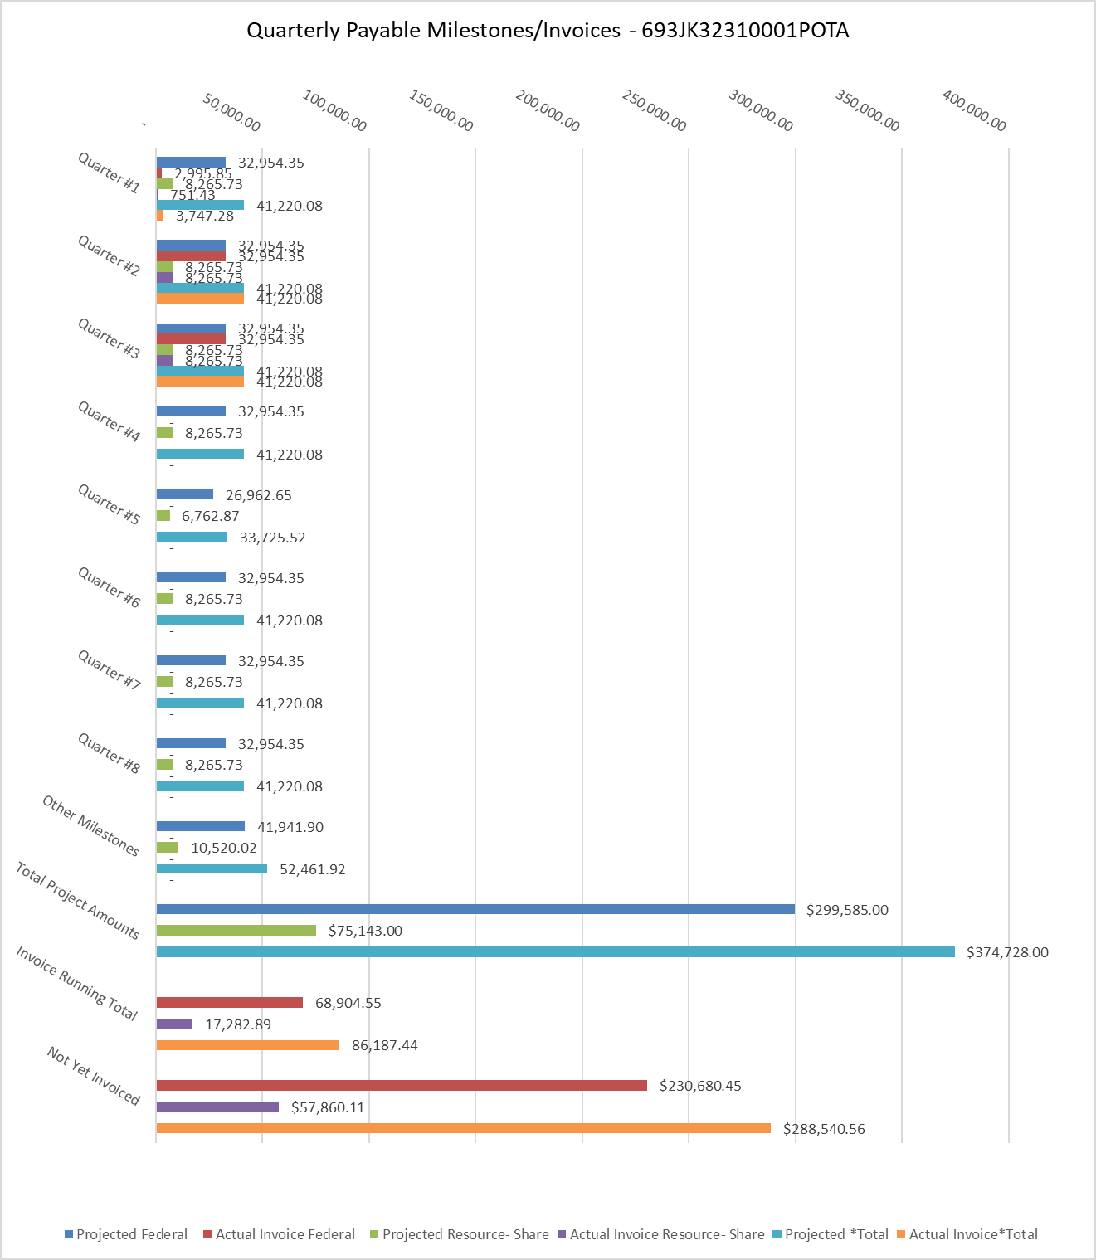

4: Project Technical Status –
We continued the third quarter of the project focused on remedial cementing jobs in gas storage wells and their differences from remedial cementing in other wells.
Underground gas storage (UGS) wells face significant challenges in maintaining well integrity, particularly in sustaining casing pressure (SCP) and preventing fluid migration through compromised cement sheaths. This paper explores advanced remedial cementing techniques and innovative materials to address these issues. Despite advancements in cementing solutions, the formation of micro-annuli and cracks due to mechanical, thermal, and hydraulic stresses remains a persistent problem. Low-viscosity sealants, poly-acrylic acid polymer solutions, and silica gels offer promising solutions because they penetrate narrow fractures and form robust seals through gelation reactions. Self-healing cement (SHCs), which activate upon contact with hydrocarbons or temperature changes, enhances well integrity by autonomously repairing cracks.
The study also highlights the importance of precise cement slurry design, including pre-flushes and spacers, and the critical role of real-time monitoring systems in ensuring successful cement placement and long-term wellbore integrity. Advanced diagnostics, such as acoustic and ultrasonic logging, provide detailed information on the condition of the cement sheath, enabling targeted remedial actions. Integrating nanotechnology into cement formulations, including using nanoparticles like nano-silica, significantly improves the mechanical properties and durability of the cement. This paper provides a comprehensive approach to addressing the challenges of sustaining SCP and ensuring the long-term integrity of UGS wells by applying advanced materials, precise cementing techniques, and innovative monitoring systems.
Our review process includes an examination of issues published in recognized industry journals such as SPE (Society of Petroleum Engineers), technical journals, company websites, and standards of practice in different countries. Our efforts include interviews with field practitioners to make sure that no techniques or technologies have been overlooked in our approach.

5: Project Schedule –
In the third quarter of the project, everything is on the track. The scheduled deliverable is going to be submitted to USDOT. The team is working to deliver the next item by the end of the second quarter.

