Internal Quarterly Report

Date of Report: 2nd Quarterly Report, April 10, 2025
Contract Number: 693JK32410004POTA
Prepared for: DOT, NYSEARCH, PLIDCO, and Acuren
Project Title: Evaluate and Assess the Development of Pipeline System Repair and Maintenance Technologies in Hydrogen (H2), H2-Natural Gas Blends, and Natural Gas Pipelines
Prepared by: DNV
Contact Information: Matt Boring, matt.boring@dnv.com, 614-761-1214
For quarterly period ending: March 31, 2025

1: Items Completed During this Quarterly Period:

Item # | Task # | Activity/Deliverable | Title | Federal Cost | Cost Share
2 | 2 | Research, summarize, and document current steel welded repair sleeves practices including in-service welding for H₂ or H₂/natural gas blended pipelines | Literature review summarizing the current steel welded repair sleeve best practices for repair of H₂ or H₂/natural gas blended pipelines. | 20,377 | 900,000
3 | 3 | Research, summarize, and document current steel bolt-on repair sleeve practices for H₂ or H₂/natural gas blended pipelines | Literature review summarizing the current steel bolt-on repair sleeve best practices for repair of H₂ or H₂/natural gas blended pipelines. | 27,695 | 0
4 | 4 | Research, summarize, and document current composite repair sleeve practices for H₂ or H₂/natural gas blended pipelines. | Literature review summarizing the current composite repair sleeve best practices for repair of H₂ or H₂/natural gas blended pipelines. | 22,024 | 750,000
5 | 5 | Research, summarize, and document current plastic pipe repair practices for H₂ or H₂/natural gas blended pipelines. | Literature review summarizing the current plastic pipe repair practices for repair of H₂ or H₂/natural gas blended pipelines. | 25,830 | 0
11 | 7 | 2nd Quarterly Status Report | Submit 2nd quarterly report | 4,520 | 0

2: Items Not-Completed During this Quarterly Period:

The project is behind schedule.

Item # | Task # | Activity/Deliverable | Title | Federal Cost | Cost Share
7 | 2 | Perform first set of in-service welding experiments on H₂ or H₂/natural gas blended pipelines | Provide the results of the welding experiments on H₂ or H₂/natural gas blended pipelines | 38,157 | 0
8 | 3 | Perform first set of LET experiments on the steel bolt-on repair sleeve elastomer in H₂ or H₂/natural gas blended environments | Provide LET testing results of the elastomer exposed in two environments | 64,143 | 0
9 | 4 | Perform permeability testing of three composite sleeve materials | Provide the permeability testing results in methane, H₂ or H₂/natural gas blended environments | 91,551 | 0
10 | 5 | Perform aging and hydrotesting of butt fusion joints | Provide the butt fusion hydrotesting results | 52,623 | 0
12 | 7 | 3rd Quarterly Status Report | Submit 3rd quarterly report | 4,520 | 0
13 | 2 | Perform second set of in-service welding experiments on H₂ or H₂/natural gas blended pipelines | Provide the results of the welding experiments on H₂ or H₂/natural gas blended pipelines | 38,157 | 0
14 | 3 | Perform second set of LET experiments on the steel bolt-on repair sleeve elastomer in H₂ or H₂/natural gas blended | Provide the LET testing results of the elastomer exposed in one environment | 21,493 | 0
15 | 4 | Perform aging and mechanical testing of three composite sleeve materials | Provide the mechanical testing results of the mechanical testing of composites in air, methane, H₂, and H₂/natural gas environments | 32,115 | 0
16 | 5 | Perform aging and hydrotesting of electrofusion joints | Provide the electrofusion hydrotesting results | 52,623 | 0
17 | 7 | 4th Quarterly Status Report | Submit 4th quarterly report | 4,520 | 0
18 | 7 | 5th Quarterly Status Report | Submit 5th quarterly report | 4,520 | 0
19 | 2 | Perform in-service welding experiments on extended exposure H₂ pipelines | Provide the results of the welding experiments on extended exposure H₂ pipelines | 26,279 | 0
20* | 6 | Prepare and submit draft final report | Submit draft final report | 45,745 | 0
21 | 7 | 6th Quarterly Status Report | Submit 6th quarterly report | 4,747 | 0
22 | N/A | Prepare and present paper at public event or publish paper in journal/magazine | Prepare and present paper at public event or publish paper in journal/magazine | 0 | 0
23 | N/A | Final virtually held information dissemination meeting | Final virtually held information dissemination meeting | 0 | 0
24 | 6 | Address comments and submit final report | Submit final report | 0 | 0
25 | 7 | Public version of final report | Submit public version of final report | 0 | 0
26 | 7 | Public research brief | Submit public research brief | 0 | 0

3: Project Financial Tracking During this Quarterly Period:

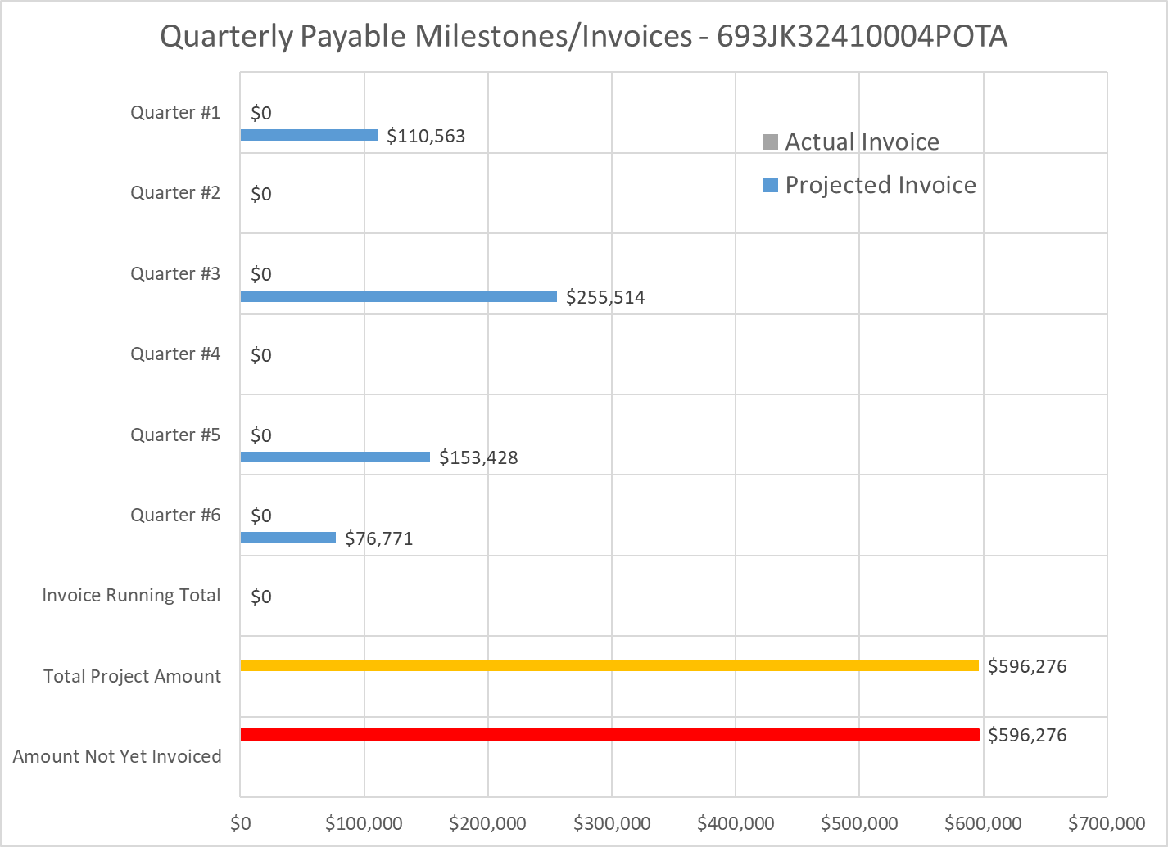

4: Project Technical Status

Task 1, Kick-off Meeting

The Project Team had a kick-off meeting that was held remotely via a TEAMS call on December 19, 2024. The meeting lasted an hour and a total of thirteen attendees including, interested parties, TAP members, PHMSA representatives. The meeting primarily covered the proposed work scope and the early findings of some of the literature review tasks that have been on-going since the start of the project. The kick-off meeting slides have been uploaded as a separate file to the project website.

Task 2, Review of Research and Proposed Research to the use of Welded Steel Repair Sleeves

The welded steel repair sleeve literature review is completed and is being compiled with the other literature reviews into a single document to review. Once the single document is compiled it will be uploaded as a draft to the project website.

The test vessels for the first set of simulated in-service welding trials and the long-term exposure trials have been fabricated and received. The long-term exposure test vessels have been pressurized with 800 psi H₂. These vessels will remain pressurized until the end of the project, at which time they will be used for final set of simulated in-service welding trials.

No PHMSA experimental testing has been completed so there are no welded steel repair sleeve experimental results that can be shared.

Task 3, Review of Research and Proposed Research to the use of Bolt-on Steel Repair Sleeves

The bolt-on steel repair sleeve literature review is completed and is being compiled with the other literature reviews into a single document to review. Once the single document is compiled it will be uploaded as a draft to the project website.

The fixture that will be used for the LET testing is being manufactured to simulate the long-term exposure of the preferred elastomer that is used for bolt-on steel repair sleeves. The LET testing will include compressing the elastomer the same amount as would be expected on installed bolt-on steel sleeves. Once the fixture is received the first LET test will begin.

PLDICO has assembled manufactured a hydrogen bolt-on steel sleeve for testing and has been installed test vessel. The PLIDCO clamp will also be exposed to hydrogen for an extended period but this trial will expose both the steel sleeve and the compressed elastomer as an assembly instead of exposing only the elastomer which is being verified during the LET testing phase. It is expected that the installed PLIDCO clamp test will begin in April. The PLIDCO project has not been completed so no results can be shared from the cost-share effort.

No PHMSA experimental testing has been completed so there are no welded steel repair sleeve experimental results that can be shared.

Task 4, Review of Research and Proposed Research to the use of Composite Repair Sleeves

The composite repair sleeve literature review is completed and is being compiled with the other literature reviews into a single document to review. Once the single document is compiled it will be uploaded as a draft to the project website.

The three composite repair system blanks have been fabricated by Acuren and are being shipped to DNV for testing. Once received, some of the material will be machined into specimens for permeability testing. The remaining materials will be prepared for aging and tensile testing based on the results for the permeability testing.

No PHMSA experimental testing has been completed so there are no composite repair sleeve experimental results that can be shared.

Task 5, Review of Research and Proposed Research for Plastic Pipe Repair

The plastic pipe repair literature review is completed and is being compiled with the other literature reviews into a single document to review. Once the single document is compiled it will be uploaded as a draft to the project website.

It was determined from the literature review that the plastic pipe that should be tested is high density polyethylene (HDPE) PE4710. HDPE was selected based on the literature review indicated that HDPE had a lower permeability then low density polyethylene (LDPE) with no significant effect on the materials mechanical properties. The specific PE4710 material was selected because it is a commonly used material for natural gas distribution based on discussions with NYSEARCH and other natural gas operators. The plastic pipe that will be testing will have a nominal diameter of 2 inch which is also a common natural gas distribution pipeline diameter and is also the same diameter of pipe that is being used in the NYSEARCH work that is a cost share to this project.

The NYSEARCH project is continuing testing and currently does not have any results that can be shared from the cost-share effort.

No PHMSA experimental testing has been completed so there are no composite repair sleeve experimental results that can be shared.

5: Project Schedule
The project is behind schedule, but it is not expected to impact the overall schedule of the project which is to end in Q1 of 2026.

Item 1, Task 1, Kick-off Meeting

Complete.

Item 2, Task 2, Steel Welded Repair Sleeves to Repair H₂ and H₂/Natural Gas blended Pipelines Literature Review

Complete and being compiled into a single document summarizing the current industry experience.

Item 3, Task 3, Steel Bolt-on Repair Sleeves to Repair H₂ and H₂/Natural Gas blended Pipelines Literature Review

Complete and being compiled into a single document summarizing the current industry experience.

Item 4, Task 4, Composite Repair Sleeves to Repair H₂ and H₂/Natural Gas blended Pipelines Literature Review

Complete and being compiled into a single document summarizing the current industry experience.

Item 5, Task 5, Plastic Pipe Repairs to Repair H₂ and H₂/Natural Gas blended Pipelines Literature Review

Complete and being compiled into a single document summarizing the current industry experience.

Item 6, Task 7, 1st Quarterly Status Report

Complete.

Item 7, Task 2, First Set of In-service Welding Trials

Vessels have been fabricated. The DNV JIP has determine what welding conditions to test under and the project team is currently determining the schedule to complete the first set of welding trials.

Item 8, Task 3, First Set of LET Experiments on the Bolt-on Steel Sleeve Elastomers

The LET test fixture is being manufactured. Once completed the LET testing will begin.

Item 9, Task 4, Composite Repair Sleeve Material Permeability Testing

The composite sleeve material blanks have been manufactured by Acuren and are being shipped to DNV for testing. Once received the composite materials will be machined into permeability test specimens and the testing will begin.

Item 10, Task 5, Aging and Hydrotesting of Butt Fusion Joints

The preferred material has been selected and the butt fusion joints are being fabricated. Once the butt fusion joints are fabricated they will be shipped to DNV for testing.

Item 11, Task 7, 2nd Quarterly Status Report

Complete.
Item 12, Task 7, 3rd Quarterly Status Report

Not started.

Item 13, Task 2, Second Set of In-service Welding Trials

Not started.

Item 14, Task 3, Second Set of LET Experiments on the Bolt-on Steel Sleeve Elastomers

Not started.

Item 15, Task 4, Composite Repair Sleeve Aging and Tensile Testing

Not started.

Item 16, Task 5, Aging and Hydrotesting of Electrofusion Joints

Not started.

Item 17, Task 7, 4th Quarterly Status Report

Not started.

Item 18, Task 7, 5th Quarterly Status Report

Not started.

Item 19, Task 2, In-service Welding Trials on Extended Exposure Pipe

The vessels have been fabricated and received. The vessels have been pressurized with 800 psi H₂ in March 2025 to begin the long-term exposure. The vessels will remain pressured until 2026 Q1 which corresponds the Q6 of the project schedule before the in-service welding trials.

Item 20, Task 6, Project Report

On-going.

Item 21, Task 7, 6th Quarterly Status Report

Not started.

