Public Quarterly Report

Date of Report: October 1, 2025 (4rth Quarterly Report)
Contract Number: 693JK32410006POTA
Prepared for: PHMSA
Project Title: Advanced Leak Detection Capabilities for Compressible Hydrocarbon Products
Prepared by: Flowstate Solutions
Contact Information: Braden Fitz-Gerald | braden.fitzgerald@flowstatesolutions.ai | 307-399-7516
For quarterly period ending: September 30, 2025

1: Items Completed During this Quarterly Period:

Item # | Task # | Activity/Deliverable | Title | Federal Cost | Cost Share
9 | 2 | Collect operational data from multiple pipeline assets to understand normal behavior and reduce false positives in leak detection. Establishing a comprehensive dataset of normal behavior is essential for accurate leak detection. | Data Collection Under Normal Operating Conditions | $9,358 | $111,752
12 | 7 | Implement and test various ML/AI models, signal processing techniques, and physical models to create POCs. Evaluate the false alarm rates and detection performance of each POC using physical withdrawal test data. POC development is crucial for feasibility testing. | Develop Proof-of-Concepts (POCs) | $13,159 | $9,726
13 | 12 | 2nd Quarterly Status Report | Submit 3rd quarterly report | $2,210 | $1,633

2: Items Not-Completed During this Quarterly Period:

Item # | Task # | Activity/Deliverable | Title | Federal Cost | Cost Share
10 | 3 | Perform controlled leak tests under various conditions and configurations to generate ground truth data for model validation and training. These tests provide critical data reflecting actual leak conditions. | Conduct Physical Withdrawal Tests | $135,179 | $4,863
11 | 4 | Analyze and document the collected data, test conditions, and observations in detailed reports to inform model development. Detailed analysis and documentation ensure the reproducibility and understanding of data and tests. | Data Analysis and Documentation | $6,579 | $4,863

3: Project Financial Tracking During this Quarterly Period:
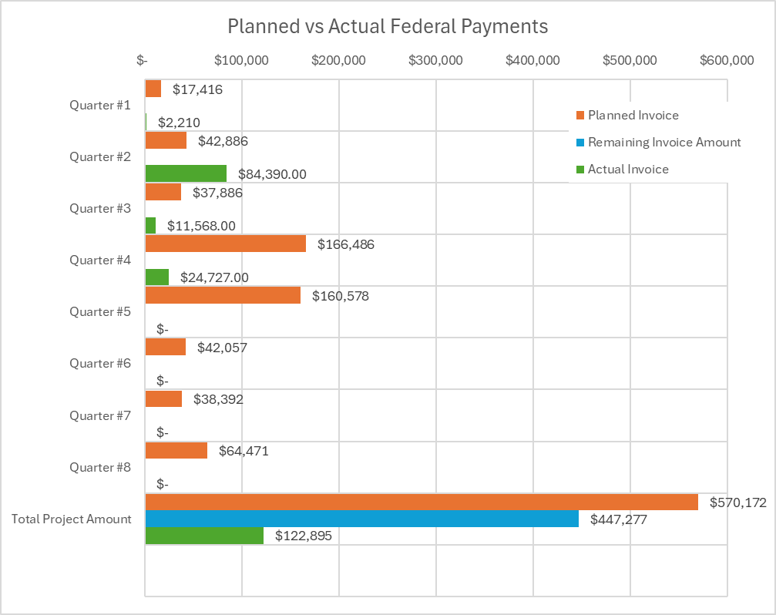

4: Project Technical Status –
Item #9, Task #2, Data Collection Under Normal Operating Conditions
We have maintained ongoing collection of normal operational data from a project partner’s compressible product system. This has provided several months of operating data across a variety of conditions, supporting both data analysis and initial proof-of-concept development. Data collection will continue throughout the project to ensure a comprehensive operating record.

Item #12, Task #7, Develop Proof-of-Concepts (POCs)
Following extensive review, we have established a machine learning–based approach for modeling compressible pipeline behavior. Compared to traditional methods, this approach reduces complexity while improving the ability to capture system dynamics during normal operations. The framework also provides indicators of model confidence, which can be used to support leak detection and anomaly identification. A working version has been applied within a project partner’s compressible product system, with additional validation across other pipeline types, demonstrating consistent performance under diverse operating conditions.

Item #13, Task #12, Submit 4th Quarterly Report
We completed and submitted the 4th quarterly report in accordance with Item #13, Task #12, as stated in Attachment #3 and corresponding to Item #13 in the Team Project Activities section (Quarterly and Monthly Reports).

5: Project Schedule
The project is currently progressing well, though we have experienced minor delays. We remain on track to conduct withdrawal tests in Q4 2025, which will bring the schedule back into alignment and, if results meet expectations, may even accelerate technical development. The primary cause of delay has been coordinating test windows with external parties and identifying viable withdrawal opportunities. Completion of these tests in Q4 will allow us to advance data analysis and validate our proof-of-concept work.

Item #10, Task #3 – Conduct Physical Withdrawal Tests
Status: In Progress
We are in the process of scheduling and finalizing agreements to move forward with physical withdrawal tests that will validate and refine our proof-of-concept approach. After considering multiple options, we elected not to use a decommissioned pipeline due to costs and logistics, and instead will be working with the Southwest Research Institute (SwRI) at their test facility. This approach has been reviewed and approved by our technical advisory panel, and we are awaiting contracting to configure the facility, establish baseline operational data, and conduct withdrawal tests under a variety of conditions. These activities are anticipated in late October or November.

In parallel, we are working with a project partner on a withdrawal test plan for a compressible product system. This plan has also been reviewed and approved by our advisory panel, and scheduling is being finalized to align with operational requirements. These tests are likewise expected in late October or November. Together, these efforts will allow us to complete data analysis and validate the proof-of-concept prior to year end.

Item #11, Task #4 – Operational Data Analysis
Status: In Progress
Following completion of the withdrawal tests with SwRI and a project partner system, we will be positioned to finalize operational data analysis and incorporate the results of physical testing. This will form the basis for validating and refining the proof-of-concept, ensuring that both analytical and experimental findings are integrated into project outcomes.

Risk Summary
The primary risk is timely execution of the withdrawal tests, which depends on coordination with external parties. Scheduling constraints and commercial considerations may cause delays, though we are actively engaged with all stakeholders to mitigate this risk.
A secondary risk is that test results could challenge the viability or sensitivity of the proof-of-concept. We consider this low risk given positive results from prior withdrawal tests on other liquid systems, where clear leak responses were observed. If required, we are prepared to refine the approach to improve detection sensitivity for compressible products.

