CAAP 2nd Annual Report

Date of Report: 10/15/2025
Prepared for: U.S. DOT Pipeline and Hazardous Materials Safety Administration
Annual Period: From 10/1/2024 to 9/30/2025
Contract Number: 693JK32050008CAAP
Project Title: Effectiveness Assessment of Pipeline Cathodic Protection System Using Remote Sensing, Advanced Modeling, and Data Analytics
Prepared by: Xingsen Yang (PhD student), Shibo Sun (PhD student); Shunjun Yu (PhD student), Hao Wang (PI), Qixin Zhou (Co-PI)
Contact Info.: Hao Wang, hwang.cee@rutgers.edu, 848-445-2874

Section A: Business and Activities
- Contract Activities
Contract Modifications: N/A
Educational Activities:
  - Student mentoring:
Three PhD students (Xingsen Yang - lead; Shibo Sun; Shunjun Yu) and Two postdocs (Jay Shah; Xiao Chen) in Civil Engineering at Rutgers worked on literature review, numerical modeling for pipe corrosion prediction and CP performance, and experimental testing with GPR and hyperspectral cameral for soil moisture measurements. Two undergraduate students (Nancy Zhang in Statistics and Praneeth Damarla in Electrical & Computer Engineering) conducted summer research on pipeline failure causes and risk assessment.
Asley Chow (undergraduate in Corrosion Engineering at U. of Akron) and Cecilia Segretario (undergraduate in Chemical Engineering at U. of Akron) worked on literature review and laboratory tests of CP performance.
  - Educational activities:
The PI introduced the knowledge of pipeline integrity management system in the graduate course – Infrastructure Management System taught at Rutgers University.
The Co-PI (Dr. Zhou) introduced the concept of cathodic protection in the undergraduate course - Introduction to Corrosion Science and Engineering at The University of Akron.
Dissemination of Project Outcomes:
A conference paper titled “Modelling Cathodic Protection Performance of Steel Pipeline under Dynamic Soil Moisture Environment” is submitted for presentation at AMPP 2026 conference.
- Financial Summary
Federal Cost Activities:
  - PI/Co-PIs/students involvement:
Graduate students’ tuition/fees/stipend are charged.
  - Materials purchased/travel/contractual (consultants/subcontractors):
Software license is purchased for multi-physics simulation; Roadscanners Percometer for measurement of dielectric constant of soil; battery for hyperspectral camera.
Budget Item | Expenses (10/1/2024 – 9/30/2025)
Faculty Salary (summer) | $7486.67
Graduate Research Assistant - Salary | $28905.74
Graduate Research Assistant - Fees | $4100
Undergraduate Stipend | $6000
Tuition | $20531
Fringe | $6172.96
Laboratory Supplies/Computer | $9785.21
Subcontract (University of Akron) | $8006.52
F&A 57% (exclude tuition and subcontract after first $25k) | $32277.45
Total | $123265.55

Cost Share Activities:
  - Cost share contribution:
Cost share is provided by PIs’ academic time as budgeted in the proposal.

- Project Schedule Update
Project Schedule: Delayed due to construction of soil box for experiments.
Corrective Actions: A one-year NCE is expected.

- Status Update of the 4th Quarter Technical Activities
Task 3: Modelling and Simulation of CP Performance
Finite element models have been developed to simulate corrosion processes under dynamic soil–atmosphere interaction. This physically based formulation enables high-resolution simulation of climate-driven water fluxes at the soil surface. However, over long timescales, the use of high-frequency climate data may result in numerical instability and elevated computational cost, which limits the method’s practicality for long-term simulations.
To address this limitation, a second approach was implemented to approximate the long-term climatic influence on surface soil suction using a semi-empirical framework based on Thornthwaite Moisture Index (TMI). TMI was computed based on historical climate records following the methodology of Saha et al. (2019). The TMI was then utilized to estimate the equilibrium surface suction (u_{e}) through a modified mechanistic-empirical model that accounts for both soil properties and local climatic conditions. Seasonal variations in suction around this equilibrium were represented using a Fourier series expansion, as proposed by Cai et al. (2022). This formulation enables the reconstruction of multi-year suction cycles in a mathematically continuous form, as shown in Equation 1.
(1)
Where, U_{i} are Fourier coefficients derived from monthly equilibrium values.
The resulting time-dependent suction profile was subsequently imposed as a boundary condition in the finite element solution of Richards' equation to simulate long-term moisture variation in the subsurface domain. Figure 1 illustrates the temporal variation of degree of saturation over a 10-year period for silt soil at three depths. A clear seasonal pattern is observed, driven by the imposed climate-derived surface boundary conditions. As expected, Sr values at deeper layers exhibit higher annual averages and reduced temporal variability due to dampened influence from surface fluctuations and increased moisture retention with depth. This depth-dependent behavior of Sr is consistent with the trends identified in the short-term simulations. Similar patterns were found in sandy and clayey soils, where sand exhibited greater fluctuations in Sr due to its low water-holding capacity, while clay displayed more stable and higher saturation levels.
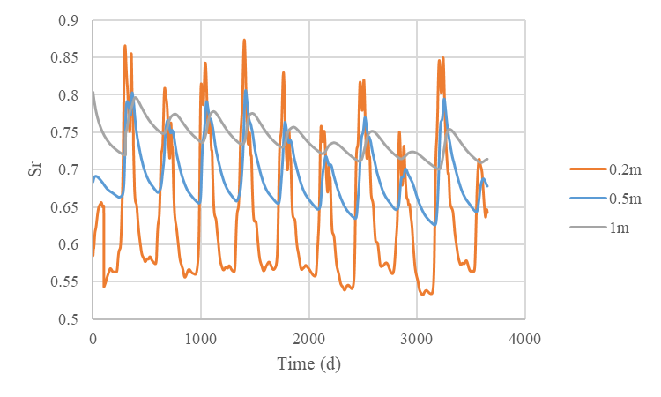
Figure 1. Long-term variation of degree of saturation in silt soil over a 10-year period at three burial depths, driven by TMI-based climatic boundary conditions.
For steel pipelines without cathodic protection, particularly in scenarios where the coating has locally failed, the formation of passive films plays a critical role in retarding long-term corrosion progression. This passivation process is governed by the accumulation and subsequent transformation of Fe²⁺/Fe³⁺ species generated during anodic dissolution. However, the persistence and effectiveness of these passive layers are strongly influenced by soil moisture conditions. At higher degrees of saturation, the increased mobility of ferrous ions promotes their dispersion away from the metal surface, thereby impeding the localized ion buildup necessary for passivation. Consequently, persistently wet environments may suppress passive layer development, leaving the steel surface more vulnerable to sustained corrosion.
Figure 9 illustrates the long-term corrosion simulation results for silt soil. Subfigure 9(a) shows the temporal evolution of corrosion current density over approximately the first three years for three different pipeline burial depths, while subfigure 9(b) illustrates the cumulative metal loss over a 20-year period.
As shown in Figure 2(a), the corrosion current density exhibits a gradually declining trend over time, with annual oscillations overlaid due to seasonal variations in moisture content. This overall reduction is attributed to the progressive development of a passive layer, which inhibits further corrosion activity. Notably, the rate of decline in corrosion current density varies with burial depth. At deeper locations, higher moisture levels hinder the retention of Fe²⁺/Fe³⁺ ions near the steel surface, thereby delaying passive film formation. Consequently, corrosion current density at these depths diminishes more slowly.
This delayed passivation effect is further reflected in Figure 2(b), where deeper burial results in significantly greater cumulative metal loss over the 20-year simulation period. Pipelines buried at 1.5 m exhibit the highest long-term corrosion, while those at 0.5 m exhibit an earlier inflection point, characterized by a marked deceleration in the rate of metal loss accumulation.
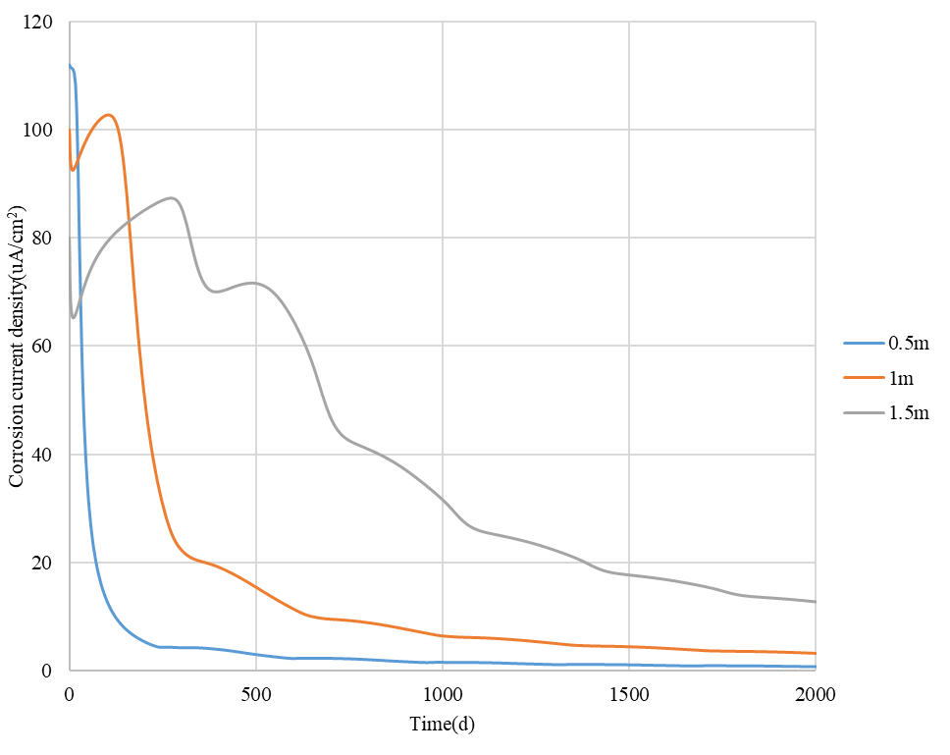
(a)
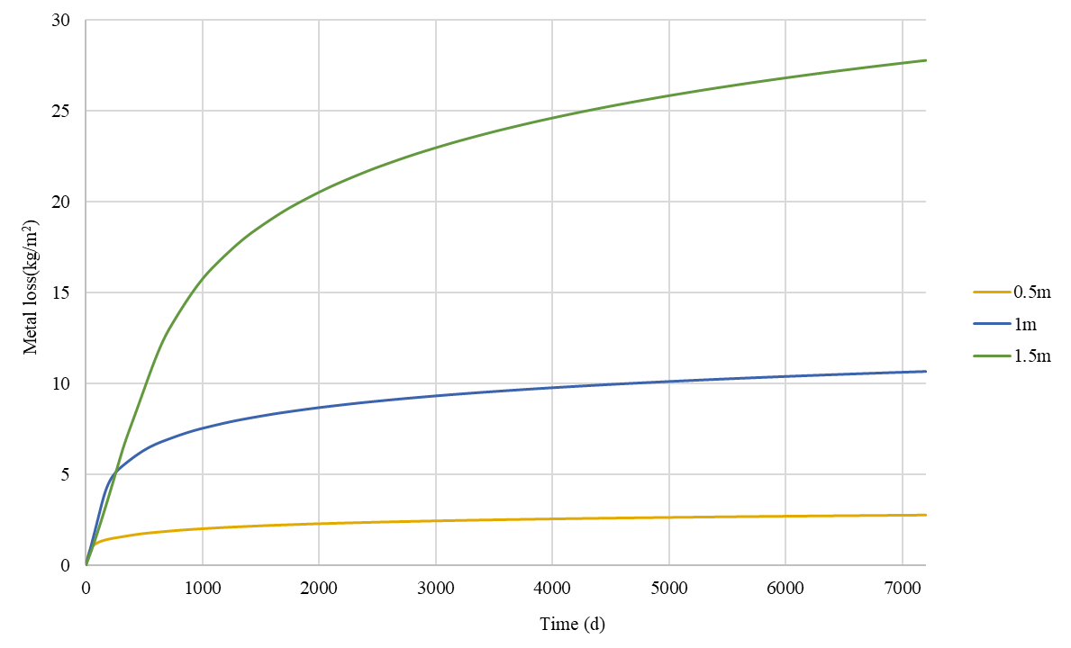
(b)
Figure 2. Long-term corrosion simulation results for silt: (a) Temporal evolution of corrosion current density at different burial depths over the first three years; (b) Cumulative metal loss over a 20-year period.
Figure 3 presents the long-term corrosion response for clay soil across different burial depths. As shown in Figure 3(a), the corrosion current density in clay exhibits smaller temporal fluctuations compared to the silt case as degree of saturation in clay varies less under the same climatic impact. Consequently, the amplitude of corrosion current density variation is also reduced. Moreover, the higher degree of saturation in clay slows the development of the passive film, leading to a more gradual decline in corrosion current density over time.
As shown in Figure 3(b), the clay group also exhibits greater long-term metal loss at deeper burial depths. While the corrosion current density in clay is generally lower in magnitude compared with silt, its high degree of saturation further delays the formation of the passive film, allowing corrosion current densities to remain at high level over a longer period. As a result, the cumulative metal loss becomes comparable to that observed in silt.
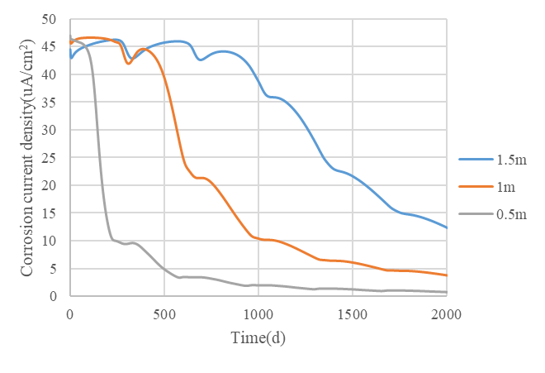
(a)
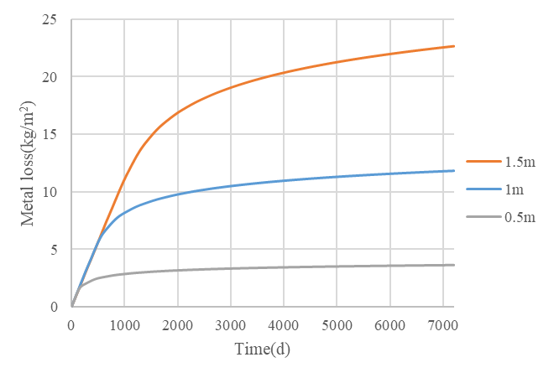
(b)
Figure 3 Long-term corrosion simulation results for clay: (a) Temporal evolution of corrosion current density at different burial depths over the first three years; (b) Cumulative metal loss over a 20-year period.
As shown in Figure 4(a), the sand group exhibits more pronounced fluctuations in corrosion current density compared to silt and clay. This is attributed to the greater variability in moisture content caused by external climatic influences. Additionally, since the degree of saturation in sand remains relatively low, the passive film develops more rapidly, leading to a faster decline in corrosion current density.
Figure 4(b) shows that the long-term metal loss curves for the three burial depths show only minor differences. This is primarily because the degree of saturation remains low at all depths, creating similar conditions for passive film formation. Additionally, owing to the intrinsically less corrosive nature of sandy soil, the cumulative metal loss over the 20-year period is significantly lower than that observed in the silt and clay groups.
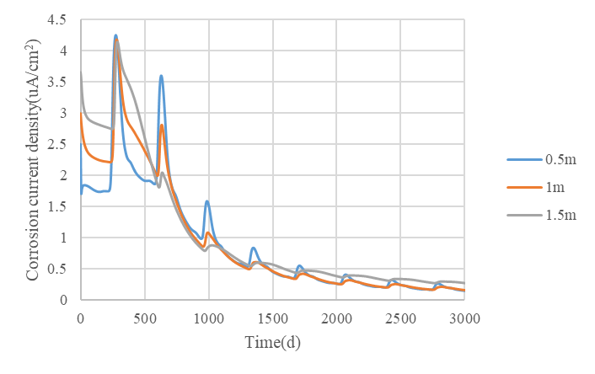
(a)
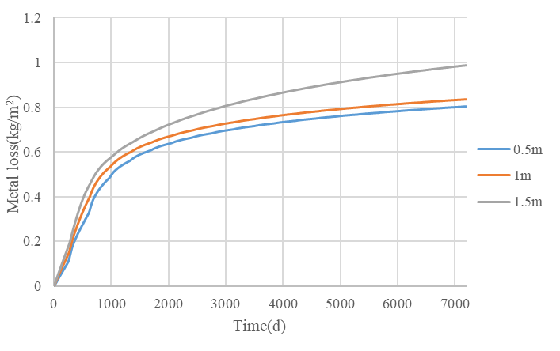
(b)
Figure 4. Long-term corrosion simulation results for sand: (a) Temporal evolution of corrosion current density at different burial depths over the first three years; (b) Cumulative metal loss over a 20-year period.
In all long-term simulation cases, corrosion current density was observed to gradually decline over time, accompanied by clear seasonal fluctuations driven by climatic cycles. This trend reflects the coupled influence of passivation development and soil moisture variability under extended environmental exposure.
In the absence of cathodic protection, the formation of passive films emerged as the primary mechanism inhibiting long-term corrosion after coating failure. The simulations further showed that soil moisture plays a critical role in influencing passivation behavior: high saturation levels were associated with delayed passivation due to enhanced dispersion of corrosion products, whereas drier conditions allowed for faster accumulation and earlier stabilization of the passive layer.
Across different soil types, distinct corrosion outcomes were observed. The sand group exhibited the lowest cumulative metal loss, owing to both its lower baseline corrosivity and the rapid development of passivation under relatively dry conditions. In contrast, although clay is inherently less corrosive than silt, its high moisture content significantly slowed passivation, resulting in a cumulative metal loss comparable to that observed in the silt group. These findings emphasize the need to incorporate passivation behavior and long-term moisture variability into corrosion risk assessments and cathodic protection design, particularly in climates where saturation levels vary seasonally around critical thresholds.

Task 4 Remote Inspection of Soil Properties and Pipe Corrosion
Hyperspectral Imaging (HSI)
Hyperspectral imaging (HSI) is a remote sensing technology that captures detailed spectral data across a broad range of the electromagnetic spectrum. Unlike traditional imaging systems, which record data in just a few broad bands (such as red, green, and blue), HSI collects information across many narrow, contiguous spectral bands (as shown in Figure 5). This allows HSI to produce a unique spectral signature for each pixel in an image, enabling the identification and analysis of various materials based on their spectral reflectance and absorption properties. HSI creates "spectral fingerprints" for materials, allowing for highly precise material identification that is not possible with conventional imaging.
The principle of HSI lies in capturing light reflected or emitted from a scene across a wide spectral range. Typically, this includes bands from the visible, near-infrared, shortwave infrared, and sometimes thermal infrared regions. Each material has a distinct spectral signature—like a unique "barcode”which can be analyzed to determine its composition or properties. HSI sensors capture the spectral data in a series of narrow bands, which are then analyzed to detect materials, assess conditions, or measure properties such as moisture content or temperature.
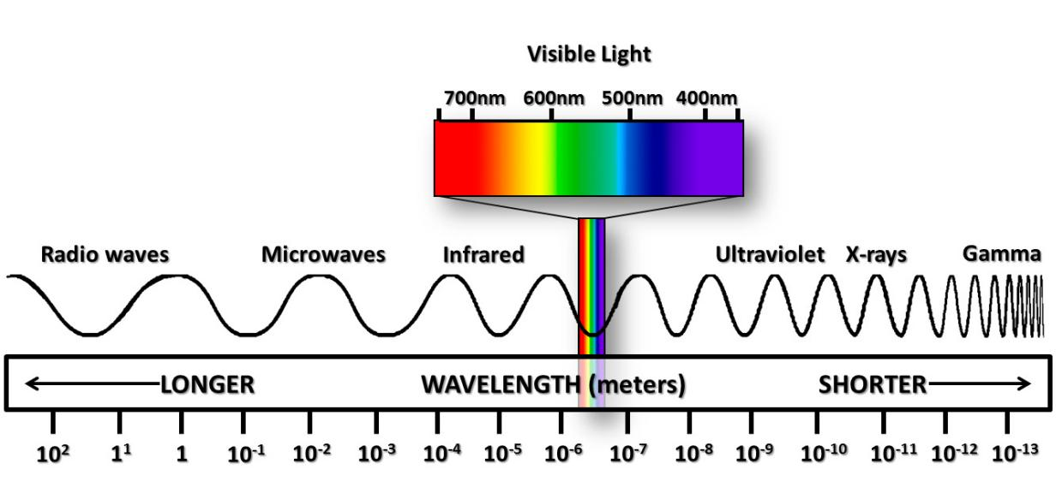
Figure 5 Electromagnetic Spectrum
Hyperspectral imaging systems can be classified in various ways based on factors such as wavelength range, sensor type, and platform used. Wavelength-based classification includes systems like Visible to Near-Infrared (VNIR), which is useful for agricultural and environmental applications, and Shortwave Infrared (SWIR), which is beneficial for mineral and water analysis. The sensor type varies from imaging spectrometers and pushbroom sensors to whiskbroom sensors, each providing different methods for capturing the spectral data. Additionally, HSI platforms can be categorized based on their location, such as satellite-based, aerial (aircraft or drones), and ground-based systems, depending on the scale and application of the data.

Testing Materials and Methods
All the soil samples were oven-dried at 105℃ for 24h to eliminate soil water. Then soil samples were sieved to 2-mm, and ground into a fine powder as pretreat (To avoid the impact of varying soil grain sizes on the reflectance spectrum). Oven-dried soil for each sample was weighed using a scale in the laboratory and then placed in a petri dish. Then samples were wet with different amounts of water. Water was sprayed into each soil sample while stirring so that the soil and water were fully mixed. After spraying, the soil sample was placed in a sealed bag with a good sealing effect and kept for 24h, with the consequence that the soil could fully absorb water.
The images were taken with a Hyspex Baldur V-1024 N hyperspectral camera and Hyspex Ground software (v4.11.5.2), manufactured by Hyspex (a division of Norsk Elektro Optikk [NEO]) in Oslo, Norway. The camera captured 113 data channels from visible and near-infrared (VNIR) bands, spanning 400–1100nm wavelengths. A lens with a 3m focal length was used, and the camera was 3m from the mixer and beaker. At 3m, the pixel resolution was roughly 0.9mm × 0.9mm. Radiometric calibration was performed on the images using Hyspex Rad software (v2.5) to convert the raw data to spectral radiance (W/(m²·steradian)). Overhead LED lighting was used in the experiment as well as a supplementary 40W incandescent light bulb to provide IR signals in the 400–1100nm range. Window curtains were lowered to minimize the impact of outdoor lighting. The placement of the camera and lighting sources is shown in Figure 6. A sample image is shown below in Figure 7 with the experiment and control data pixels outlined in boxes. Three samples of pixels were taken from each image: 20 × 30 pixels of soil data at the bottom of the beaker where the sediment was fully mixed and 15 × 20 pixels of control data from both the black and white image background. For both the sediment and control samples, the average and standard deviation were calculated across the horizontal and vertical dimensions, and these data were stored for each of the 113 data channels (113 × 30 × 20 data recorded per image).
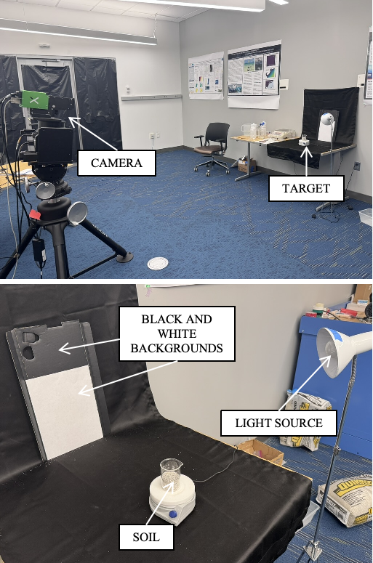
Figure 6 Experiment configuration showing the positions of the beaker, black and white background, camera, and supplemental light source.
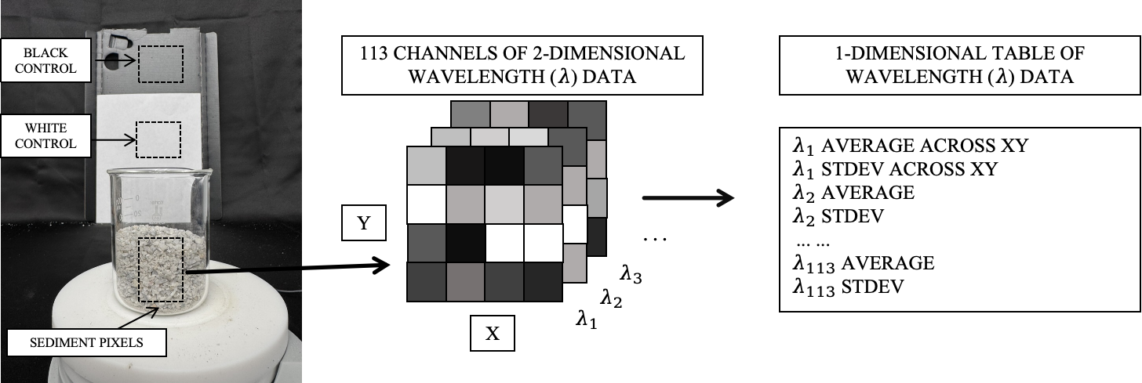
Figure 7 The location and data processing of raw images.

Effect of Soil Moisture Contents
Soil moisture content is a critical factor influencing soil health, plant growth, and agricultural productivity. The ability to monitor it accurately and efficiently is essential for optimizing irrigation practices, managing water resources, and assessing the impact of climate change on soil systems. Traditional methods, such as soil probes, gravimetric techniques, and time-domain reflectometry, are labor-intensive, invasive, and time-consuming. In contrast, hyperspectral imaging (HSI), a non-invasive and high-throughput remote sensing technique, offers a promising alternative for estimating this essential property.
A total of 450 g of air-dried soil was used for the moisture-spectral response experiment. Distilled water was incrementally added to the soil in 10% moisture content intervals (10%, 20%, … up to 80% by weight). After each water addition, the soil was thoroughly stirred to achieve homogeneity. Figure 8 shows the spectral radiance curves of soil samples at different moisture contents across the 400–1100 nm range.
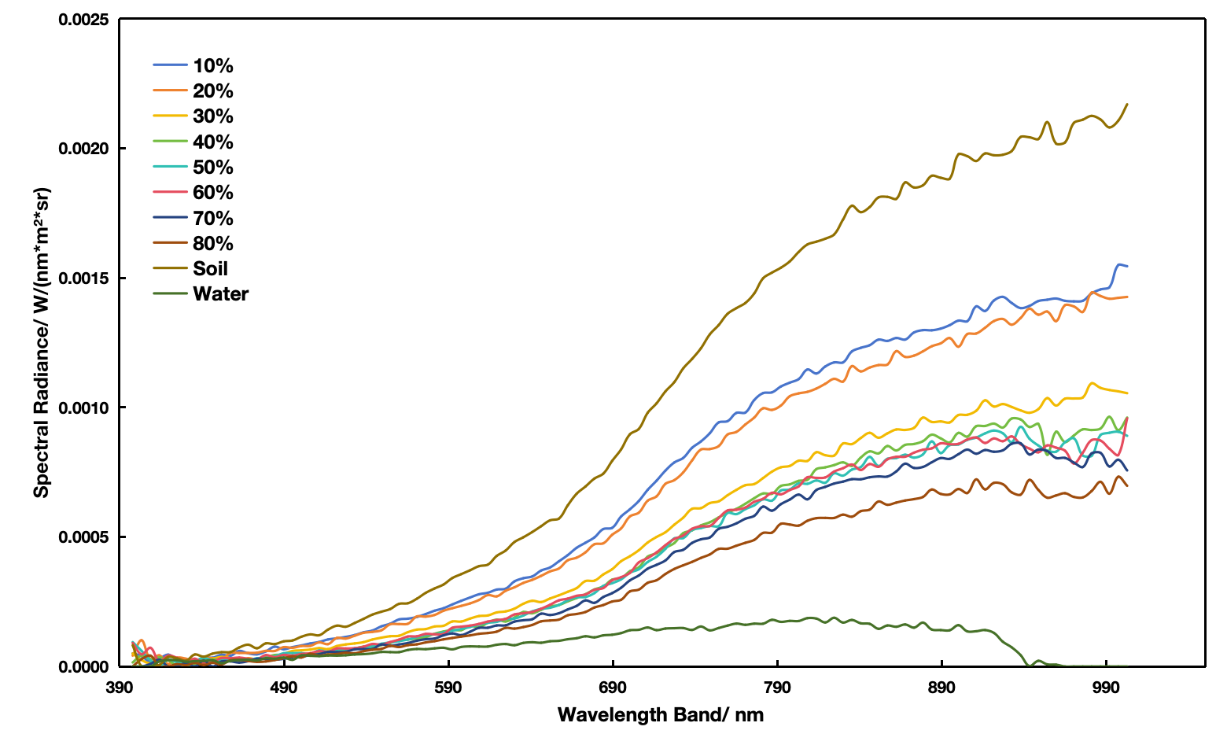
Figure 8 Soil reflectance spectra of samples at different moisture contents.
The hyperspectral measurements under different moisture conditions revealed that soil spectral radiance increased with wavelength across the 400–1100nm range, but the magnitude of this increase was strongly influenced by water content. Radiance values rose steadily as soil moisture increased from 10% to approximately 25%, beyond which the spectral behavior changed markedly. At 25% gravimetric moisture, the soil reached its saturation threshold, and further addition of water led to a pronounced reduction and divergence in spectral intensity. Samples with moisture contents of 30% or greater exhibited substantially lower radiance compared with the unsaturated range, and the curves increasingly resembled the spectral signature of pure water. These results indicate that soil saturation represents a critical transition point, after which free water dominates the optical response and masks intrinsic soil spectral features.
Closer inspection of the spectral curves demonstrates that the influence of moisture is wavelength dependent. At shorter wavelengths (<600nm), spectral radiance was generally low across all treatments, with minimal separation between moisture levels. However, differences became more pronounced in the red-edge region (~700nm) and especially in the near-infrared range (>700nm), where water absorption dominates. Soils with higher moisture contents exhibited progressive suppression of spectral radiance, with the 80% moisture treatment showing the lowest reflectance values, closely approaching that of the pure water reference. In contrast, the driest sample (10% moisture) displayed the highest radiance, characterized by a steady increase from the visible into the near infrared. The intermediate “Soil” reference curve fell between the dry and saturated conditions, while the water reference remained near zero across the measured wavelengths, confirming the strong absorptivity of water in the VNIR domain.
The reduction in spectral radiance with increasing water content can be attributed to two complementary mechanisms. First, liquid water has strong absorption features in the VNIR region, particularly in the near-infrared, which directly attenuate the outgoing radiance. Second, as water occupies soil pores and coats mineral particles, it alters the soil–air interface and reduces multiple scattering within the soil matrix, thereby lowering overall reflectance. Together, these mechanisms highlight the dominant role of moisture in shaping soil spectral responses and underscore the importance of carefully controlling or modeling soil water content in hyperspectral studies.

Effect of Soil pH Values
Soil pH is one of the most crucial parameters for understanding soil health and fertility. It directly influences nutrient availability, microbial activity, and overall plant growth. Traditional methods for measuring soil pH involve laboratory-based techniques, such as pH meters and soil extraction methods, which can be time-consuming, labor-intensive, and spatially limited. Hyperspectral imaging (HSI) has emerged as a promising alternative, offering a non-invasive, rapid, and large-scale approach to measuring soil pH with high accuracy.
To establish the relationship between acid addition and equilibrium soil pH, a titration experiment was conducted under fixed-moisture conditions. Air-dried bulk soil was gently disaggregated, sieved to below 2mm, and weighed into 50g portions (oven-dry equivalent). The gravimetric moisture content was adjusted to 20% (w/w), corresponding to a total liquid input of 10.0mL per cup, including both 0.1M HCl and deionized (DI) water. Treatment solutions were prepared by combining different volumes of 0.1M HCl with DI water to make a constant total of 10.0mL. The acid gradient was designed to span the anticipated pH range, with nine levels ranging from 0.00 to 2.00mL HCl in 0.25mL increments.
The treatment solution was added to the soil in three successive portions, with thorough mixing after each addition to ensure uniform distribution. Following application, the samples were sealed with lids or parafilm to minimize evaporation and allowed to equilibrate at room temperature (22 ± 2 °C) for 60 min. To assess the equilibrium pH, a subsample was extracted and mixed with DI water at a 1:2.5 soil-to-water ratio (10g soil: 25 mL water). The slurry was stirred for 1 min, rested for 10 min, and measured using a calibrated pH meter (daily three-point calibration at pH 4.00, 7.00, and 10.00 with automatic temperature compensation). Triplicate measurements were averaged, and any samples showing unstable readings (>0.05 pH unit drift over 60 s) were remixed and remeasured.
As shown in Figure 9, the titration of the soil with 0.1M HCl revealed a clear, stepwise decrease in pH with incremental acid additions, reflecting the soil’s inherent buffering capacity. The initial pH of the untreated soil was approximately 8.0, indicating an alkaline baseline condition. As acid was added, the pH did not decline linearly but instead exhibited distinct buffering zones. A first plateau was observed in the near-neutral range, where the pH decreased gradually from 7.0 to 6.0 after approximately 2–3mL of acid had been added. A second buffering interval occurred between pH 6.0 and 5.0, requiring 4–5mL of acid for the transition. The strongest buffering response was recorded in the moderately acidic range, where pH shifted from 5.0 to 4.0 only after 7–8mL of acid addition. Beyond this point, the curve flattened, and the pH stabilized near 4.0 despite further increments of acid input.
These results demonstrate that the soil possesses multiple buffering mechanisms associated with different chemical constituents, such as carbonates near neutrality and exchangeable cations in more acidic conditions. The presence of these discrete buffering plateaus highlights the importance of carefully controlling acid inputs when preparing soils at defined target pH values. Specifically, to achieve pH 6.0, 5.0, or 4.0 for subsequent spectral experiments, the titration curve provides a direct reference for calculating the required HCl dose.
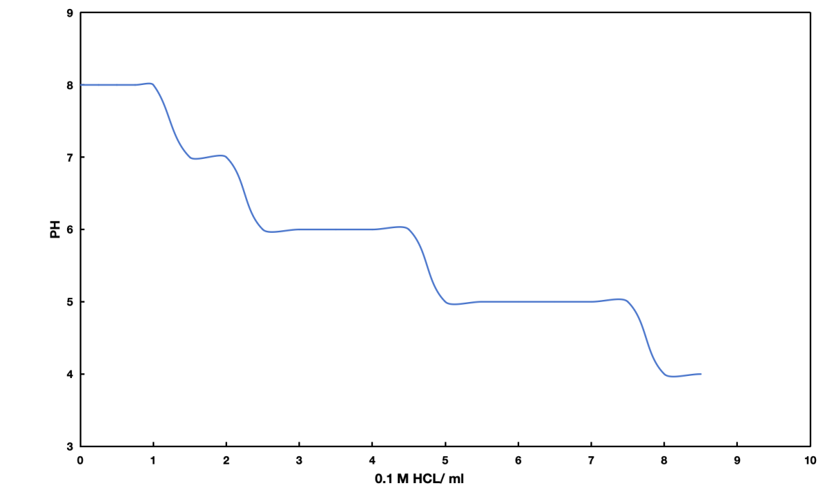
Figure 9 Relationship between equilibrium soil pH and acid dose (0.1 M HCl) at 20% moisture.
The hyperspectral measurements revealed systematic differences in spectral radiance among soils treated to different pH levels, as shown in Figure 10. Across the measured range of 400–1100nm, spectral radiance increased steadily with wavelength, consistent with the general reflectance behavior of mineral soils. However, distinct effects of pH were observed in both the magnitude and shape of the curves. Soils maintained at higher pH values (pH 7.0–8.0) exhibited consistently greater reflectance across the spectrum compared to their acidified counterparts. In contrast, samples adjusted to lower pH levels (pH 5.0–4.0) showed markedly reduced spectral intensity, with the difference being most pronounced in the visible to near-infrared region (approximately 600–900nm).
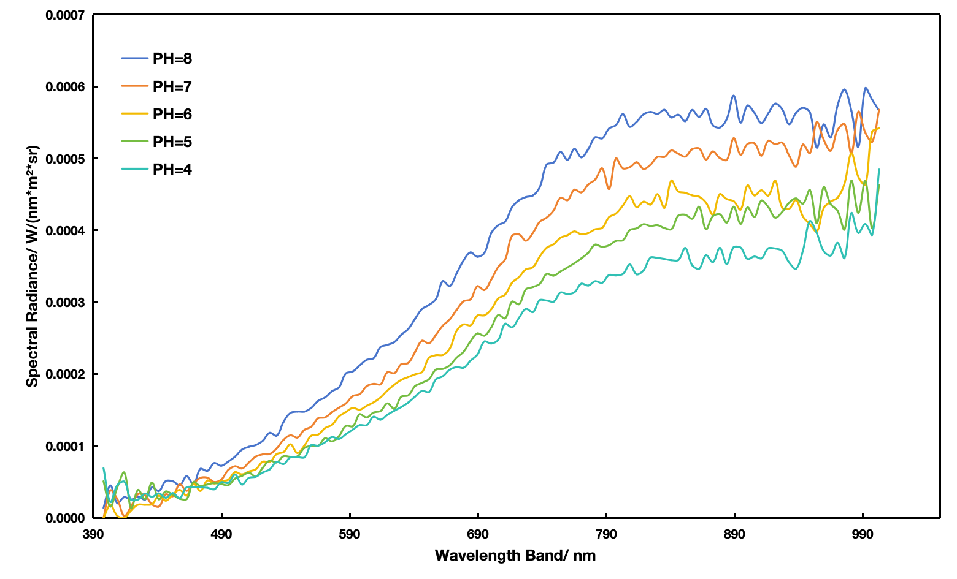
Figure 10 Hyperspectral radiance of soils adjusted to different pH levels at 20% moisture.
These results indicate that soil acidification leads to a progressive attenuation of radiance, particularly in wavelengths associated with organic matter absorption and iron oxide features. The sensitivity of hyperspectral signatures to pH suggests that spectral data can be used not only to distinguish acidic from alkaline soils, but also to quantify the degree of acidification when supported by calibration models. This relationship provides a foundation for developing predictive models of soil pH based on hyperspectral imaging.

Section B: Detailed Technical Results in the Report Period

Background and Objectives in the 1st Annual Report Period
The work in the 1st year is mainly to 1) conduct literature review, 2) develop laboratory test plan, and 3) develop an electro-chemical-soil model for CP effectiveness assessment.

Research Progress
Task 1: Literature Review, Information Collection, and Refinement of Work Plan --- Completed
The research team has completed literature review including the topics related to 1) CP system design principle, 2) factors affecting CP effectiveness (soil condition, coating, AC/DC current, etc.), and 3) CP effectiveness assessment methods (laboratory, field, numerical modeling, data-driven).
The PI had an online meeting with the industry partner (one pipeline operator) to discuss and refine the project plan. The PI attended the annual conference of Association for Materials Protection and Performance (AMPP) in March 2024 and discussed the project with the industry partner (one consulting firm) to obtain feedback on project plan.
Task 2: Laboratory Tests of CP Performance under Various Factors --- Ongoing
The task is to study the effectiveness of CP through electrochemical measurements in the laboratory and provide benchmark data for CP model validation. The research team has conducted short-term corrosion test using the sand soil at different moisture contents and CP levels. The potentiostat and electrochemical experiments were performed to measure and calculate mass loss of steel coupons at different conditions. The results show both soil moisture content and CP levels affect corrosion development.
Task 3: Modelling and Simulation of CP Performance --- Ongoing
This task is to develop a coupled electro-chemical-soil model for CP effectiveness assessment and evaluate the major factors having significant influences. The research team has developed and validated the corrosion model for steel pipe in the soil. The corrosion model includes characterization of two phenomena. One is electrochemical reactions on the pipeline steel surface; the other is oxygen diffusion and moisture transport during the electrochemical reactions. This allows for the spatial and temporal resolution of corrosion current density as influenced by subsurface saturation dynamics, burial depths, and soil types, To accurately simulate CP performance, the transport of chemical species is coupled with electrochemical reactions, which enables the model to take the changing environment conditions into account.
Two boundary conditions are used in the model to simulate the ambient environment. The first method focuses on short-term simulation of corrosion rate that explicitly incorporates time-varying climatic inputs, such as rainfall and evaporation into a coupled soil moisture and corrosion system. The second method extends the analysis to long-term performance by incorporating the Thornthwaite Moisture Index (TMI), a representative climate-based indicator of hydrological variability over extended periods.
Task 4 Remote Inspection of Soil Properties and Pipe Corrosion --- Ongoing
Ground Penetrating Radar (GPR) is used to measure volumetric moisture content (VWC) of soil above the buried pipe. To simulate realistic environments, a sandbox testbed was constructed in the field, embedding a steel plate and three steel pipes with different diameters and surface corrosion levels. GPR tests were conducted repeatedly over a seven-month monitoring period to capture electromagnetic responses under changing VMC. The results reveal that the travel time of waves reflected from metallic objects increased with higher average soil VMC.
Hyperspectral imaging (HSI) is also used to measure soil moisture contents and pH values. Laboratory tests with HSI were conducted using the same soil for GPR testing. The preliminary results show that both moisture contents and pH values affect the hyperspectral radiance of soils across a wide range of wavelengths.

Future work
Task 2: An experimental design and testing protocols for investigating metal corrosion under different soil conditions with CP will be undertaken. The metal, soil, and testing conditions for CP will be identified and investigated.

Task 3: An electro-chemical-soil model will be refined and validated through laboratory experiments and then used to quantify the influencing factors on CP effectiveness.

Task 4: The remote inspection methods of soil properties and corrosion will be investigated based on laboratory tests using GPR and HIS.

